**CÁLCULO MENTAL**

**SEGUNDO GRADO**

***Sumas y restas 2***

|  |  |  |  |  |  |  |  |
| --- | --- | --- | --- | --- | --- | --- | --- |
|  | **A** | **B** | **C** | **D** | **E** | **F** | **G** |
| **1** | **9 + 11** | **23 - 10** | **21 + 21** | **32 - 12** | **27 + 6** | **54 - 11** | **35 + 20** |
| **2** | **28 - 5** | **12 + 12** | **24 + 12** | **13 + 17** | **43 - 20** | **32 + 32** | **43 - 13** |
| **3** | **34 + 7** | **45 - 12** | **46 + 30** | **46 - 4** | **13 + 13** | **15 + 21** | **32 + 18** |
| **4** | **45 - 30** | **32 + 32** | **72 - 22** | **18 + 7** | **45 - 11** | **33 + 40** | **17 - 4** |
| **5** | **13 + 13** | **21 + 15** | **54 + 16** | **53 - 30** | **43 + 43** | **43 - 13** | **58 + 4** |
| **6** | **25 - 12** | **47 + 30** | **19 - 6** | **14 + 14** | **22 + 13** | **65 + 15** | **77 - 40** |
| **7** | **34 + 34** | **74 - 14** | **76 + 5** | **29 - 13** | **61 + 30** | **24 - 2** | **15 + 15** |
| **8** | **34 + 13** | **71 + 19** | **59 - 20** | **26 + 26** | **56 - 26** | **87 + 5** | **62 - 11** |
| **9** | **72 + 20** | **27 - 3** | **16 + 16** | **12 + 17** | **57 + 13** | **81 - 50** | **34 + 34** |
| **10** | **49 - 19** | **38 + 3** | **43 - 12** | **34 + 40** | **28 - 6** | **17 + 17** | **13 + 15** |
| **11** | **28 + 12** | **42 - 20** | **23 + 23** | **83 - 13** | **57 + 5** | **43 - 12** | **40 + 23** |
| **12** | **34 - 2** | **18 + 18** | **31 + 13** | **22 + 18** | **74 - 30** | **24 + 24** | **45 - 15** |
| **13** | **23 + 5** | **34 - 12** | **40 + 18** | **26 - 5** | **29 + 29** | **18 + 41** | **26 + 14** |
| **14** | **83 - 50** | **39 + 39** | **57 - 17** | **19 + 4** | **33 - 12** | **17 + 50** | **39 - 5** |
| **15** | **39 + 39** | **42 + 13** | **41 + 29** | **34 - 10** | **25 + 25** | **32 - 22** | **17 + 6** |
| **16** | **54 - 11** | **40 + 26** | **47 - 5** | **43 + 43** | **32 + 15** | **24 + 16** | **61 - 20** |
| **17** | **46 + 46** | **67 - 17** | **36 + 7** | **35 - 14** | **50 + 19** | **78 - 5** | **26 + 26** |
| **18** | **14 + 32** | **22 + 18** | **37 - 10** | **31 + 31** | **43 - 33** | **69 + 3** | **45 - 14** |
| **19** | **34 + 40** | **76 - 2** | **46 + 46** | **21 + 25** | **12 + 18** | **64 - 40** | **42 + 42** |
| **20** | **32 - 12** | **43 + 3** | **65 - 4** | **30 + 14** | **17 - 5** | **13 + 13** | **23 + 11** |

**HOJA DE RESPUESTAS**

***Sumas y restas 2***

|  |  |  |  |  |  |  |  |
| --- | --- | --- | --- | --- | --- | --- | --- |
|  | **A** | **B** | **C** | **D** | **E** | **F** | **G** |
| **1** |  |  |  |  |  |  |  |
| **2** |  |  |  |  |  |  |  |
| **3** |  |  |  |  |  |  |  |
| **4** |  |  |  |  |  |  |  |
| **5** |  |  |  |  |  |  |  |
| **6** |  |  |  |  |  |  |  |
| **7** |  |  |  |  |  |  |  |
| **8** |  |  |  |  |  |  |  |
| **9** |  |  |  |  |  |  |  |
| **10** |  |  |  |  |  |  |  |
| **11** |  |  |  |  |  |  |  |
| **12** |  |  |  |  |  |  |  |
| **13** |  |  |  |  |  |  |  |
| **14** |  |  |  |  |  |  |  |
| **15** |  |  |  |  |  |  |  |
| **16** |  |  |  |  |  |  |  |
| **17** |  |  |  |  |  |  |  |
| **18** |  |  |  |  |  |  |  |
| **19** |  |  |  |  |  |  |  |
| **20** |  |  |  |  |  |  |  |

**CÁLCULO MENTAL**

**SEGUNDO GRADO**

***Sumas y restas 3***

|  |  |  |  |  |  |  |  |
| --- | --- | --- | --- | --- | --- | --- | --- |
|  | **A** | **B** | **C** | **D** | **E** | **F** | **G** |
| **1** | **10 + 30** | **100 + 200** | **600 - 400** | **20 + 60** | **90 - 60** | **400 + 200** | **80 + 10** |
| **2** | **60 - 40** | **600 - 200** | **60 - 20** | **600 - 300** | **900 - 300** | **90 - 70** | **800 - 300** |
| **3** | **200 + 700** | **30 + 50** | **20 + 40** | **10 + 90** | **300 + 800** | **60 + 10** | **400 + 500** |
| **4** | **900 - 700** | **90 – 30** | **900 - 200** | **800 + 600** | **40 - 20** | **900 + 300** | **50 + 20** |
| **5** | **70 + 20** | **20 + 20** | **10 + 70** | **90 - 50** | **40 + 10** | **30 + 20** | **90 - 80** |
| **6** | **600 - 500** | **800 + 400** | **20 - 10** | **500 - 300** | **20 + 80** | **700 - 600** | **600 - 100** |
| **7** | **50 + 80** | **60 - 30** | **100 + 400** | **300 + 600** | **50 - 30** | **50 - 20** | **60 + 80** |
| **8** | **90 - 20** | **90 + 40** | **90 - 40** | **800 - 200** | **60 + 60** | **200 + 300** | **30 - 10** |
| **9** | **400 + 700** | **700 - 500** | **800 + 500** | **80 + 70** | **400 - 100** | **900 - 600** | **200 + 500** |
| **10** | **800 - 500** | **200 + 900** | **50 + 60** | **80 - 60** | **100 + 800** | **40 + 80** | **900 - 500** |
| **11** | **70 + 40** | **80 - 40** | **500 - 200** | **100 + 600** | **80 - 70** | **50 - 40** | **80 - 20** |
| **12** | **50 - 10** | **70 + 60** | **80 - 50** | **60 - 10** | **40 + 60** | **900 - 400** | **50 + 40** |
| **13** | **90 + 50** | **800 - 100** | **70 + 90** | **600 + 700** | **800 + 900** | **70 + 50** | **500 + 900** |
| **14** | **80 - 30** | **60 + 30** | **600 + 500** | **30 - 20** | **400 - 200** | **700 + 300** | **70 + 70** |
| **15** | **600 + 200** | **600 + 400** | **70 - 50** | **40 + 40** | **90 + 80** | **90 - 10** | **60 - 50** |
| **16** | **40 + 30** | **40 - 10** | **90 + 60** | **700 - 200** | **600 + 900** | **30 + 90** | **900 + 700** |
| **17** | **700 - 300** | **90 + 20** | **800 - 400** | **500 + 300** | **500 - 100** | **500 + 700** | **80 + 30** |
| **18** | **90 + 90** | **700 - 400** | **30 + 30** | **70 - 60** | **30 + 70** | **70 - 10** | **800 - 600** |
| **19** | **800 + 200** | **400 + 900** | **40 - 30** | **500 - 400** | **80 - 10** | **80 + 80** | **700 + 800** |
| **20** | **70 - 30** | **70 - 40** | **300 + 400** | **10 + 50** | **500 + 500** | **900 - 100** | **70 - 20** |

**HOJA DE RESPUESTAS**

***Sumas y restas 3***

|  |  |  |  |  |  |  |  |
| --- | --- | --- | --- | --- | --- | --- | --- |
|  | **A** | **B** | **C** | **D** | **E** | **F** | **G** |
| **1** |  |  |  |  |  |  |  |
| **2** |  |  |  |  |  |  |  |
| **3** |  |  |  |  |  |  |  |
| **4** |  |  |  |  |  |  |  |
| **5** |  |  |  |  |  |  |  |
| **6** |  |  |  |  |  |  |  |
| **7** |  |  |  |  |  |  |  |
| **8** |  |  |  |  |  |  |  |
| **9** |  |  |  |  |  |  |  |
| **10** |  |  |  |  |  |  |  |
| **11** |  |  |  |  |  |  |  |
| **12** |  |  |  |  |  |  |  |
| **13** |  |  |  |  |  |  |  |
| **14** |  |  |  |  |  |  |  |
| **15** |  |  |  |  |  |  |  |
| **16** |  |  |  |  |  |  |  |
| **17** |  |  |  |  |  |  |  |
| **18** |  |  |  |  |  |  |  |
| **19** |  |  |  |  |  |  |  |
| **20** |  |  |  |  |  |  |  |

**CÁLCULO MENTAL**

**SEGUNDO GRADO**

***Tablas multiplicar 2***

|  |  |  |  |  |  |  |  |
| --- | --- | --- | --- | --- | --- | --- | --- |
|  | **A** | **B** | **C** | **D** | **E** | **F** | **G** |
| **1** | **2 x 1** | **8 x 4** | **9 x 11** | **6 x 3** | **8 x 7** | **6 x 5** | **7 x 0** |
| **2** | **8 x 0** | **7 x 6** | **8 x 5** | **7 x 1** | **6 x 4** | **7 x 3** | **8 x 2** |
| **3** | **12 x 2** | **4 x 5** | **2 x 3** | **5 x 5** | **5 x 0** | **2 x 6** | **4 x 3** |
| **4** | **4 x 4** | **6 x 1** | **3 x 0** | **2 x 4** | **7 x 2** | **8 x 1** | **3 x 5** |
| **5** | **5 x 2** | **2 x 2** | **5 x 4** | **8 x 10** | **2 x 5** | **6 x 0** | **6 x 6** |
| **6** | **3 x 6** | **5 x 3** | **4 x 6** | **4 x 0** | **5 x 6** | **3 x 4** | **2 x 7** |
| **7** | **8 x 3** | **9 x 0** | **6 x 2** | **3 x 2** | **8 x 11** | **5 x 7** | **9 x 8** |
| **8** | **6 x 7** | **3 x 7** | **7 x 7** | **8 x 6** | **3 x 3** | **4 x 2** | **7 x 4** |
| **9** | **9 x 9** | **4 x 11** | **3 x 1** | **4 x 7** | **5 x 10** | **7 x 10** | **5 x 1** |
| **10** | **7 x 5** | **6 x 10** | **8 x 9** | **2 x 15** | **4 x 1** | **9 x 7** | **4 x 9** |
| **11** | **6 x 9** | **9 x 2** | **3 x 10** | **10 x 2** | **3 x 11** | **4 x 8** | **7 x 11** |
| **12** | **9 x 1** | **8 x 8** | **5 x 8** | **3 x 9** | **9 x 5** | **15 x 3** | **10 x 5** |
| **13** | **8 x 7** | **3 x 8** | **9 x 3** | **7 x 8** | **10 x 3** | **2 x 9** | **9 x 7** |
| **14** | **10 x 6** | **20 x 3** | **6 x 11** | **5 x 9** | **15 x 2** | **9 x 6** | **6 x 8** |
| **15** | **2 x 11** | **8 x 1** | **30 x 2** | **9 x 4** | **5 x 1** | **11 x 2** | **15 x 4** |
| **16** | **20 x 2** | **9 x 10** | **10 x 1** | **11 x 7** | **7 x 9** | **10 x 4** | **11 x 3** |
| **17** | **9 x 1** | **10 x 7** | **12 x 4** | **20 x 5** | **2 x 8** | **4 x 1** | **2 x 10** |
| **18** | **11 x 4** | **12 x 3** | **11 x 6** | **6 x 1** | **11 x 1** | **5 x 11** | **20 x 8** |
| **19** | **20 x 9** | **11 x 5** | **20 x 4** | **12 x 5** | **10 x 9** | **20 x 7** | **3 x 1** |
| **20** | **4 x 10** | **20 x 10** | **7 x 6** | **10 x 8** | **20 x 6** | **10 x 10** | **10 x 11** |

**HOJA DE RESPUESTAS**

***Tablas multiplicar 2***

|  |  |  |  |  |  |  |  |
| --- | --- | --- | --- | --- | --- | --- | --- |
|  | **A** | **B** | **C** | **D** | **E** | **F** | **G** |
| **1** |  |  |  |  |  |  |  |
| **2** |  |  |  |  |  |  |  |
| **3** |  |  |  |  |  |  |  |
| **4** |  |  |  |  |  |  |  |
| **5** |  |  |  |  |  |  |  |
| **6** |  |  |  |  |  |  |  |
| **7** |  |  |  |  |  |  |  |
| **8** |  |  |  |  |  |  |  |
| **9** |  |  |  |  |  |  |  |
| **10** |  |  |  |  |  |  |  |
| **11** |  |  |  |  |  |  |  |
| **12** |  |  |  |  |  |  |  |
| **13** |  |  |  |  |  |  |  |
| **14** |  |  |  |  |  |  |  |
| **15** |  |  |  |  |  |  |  |
| **16** |  |  |  |  |  |  |  |
| **17** |  |  |  |  |  |  |  |
| **18** |  |  |  |  |  |  |  |
| **19** |  |  |  |  |  |  |  |
| **20** |  |  |  |  |  |  |  |

**CÁLCULO MENTAL**

**SEGUNDO GRADO**

***Multiplicaciones 2***

|  |  |  |  |  |  |  |  |
| --- | --- | --- | --- | --- | --- | --- | --- |
|  | **A** | **B** | **C** | **D** | **E** | **F** | **G** |
| **1** | **15 x 2** | **12 x 5** | **13 x 9** | **14 x 10** | **15 x 11** | **20 x 9** | **10 x 11** |
| **2** | **28 x 5** | **21 x 9** | **32 x 10** | **21 x 11** | **90 x 9** | **80 x 11** | **23 x 2** |
| **3** | **15 x 9** | **53 x 10** | **41 x 11** | **70 x 9** | **20 x 11** | **31 x 2** | **46 x 5** |
| **4** | **20 x 11** | **25 x 2** | **14 x 5** | **12 x 9** | **17 x 10** | **13 x 11** | **30 x 9** |
| **5** | **24 x 2** | **32 x 5** | **22 x 9** | **36 x 10** | **22 x 11** | **90 x 5** | **90 x 11** |
| **6** | **48 x 5** | **12 x 9** | **62 x 10** | **45 x 11** | **60 x 9** | **30 x 11** | **32 x 2** |
| **7** | **40 x 9** | **30 x 11** | **35 x 2** | **16 x 5** | **14 x 9** | **21 x 10** | **14 x 11** |
| **8** | **9 x 11** | **22 x 2** | **34 x 5** | **25 x 9** | **38 x 10** | **23 x 11** | **80 x 5** |
| **9** | **33 x 2** | **52 x 5** | **55 x 9** | **65 x 10** | **33 x 11** | **70 x 5** | **4 x 11** |
| **10** | **15 x 11** | **50 x 9** | **40 x 11** | **45 x 2** | **18 x 5** | **15 x 9** | **27 x 10** |
| **11** | **70 x 5** | **8 x 11** | **26 x 2** | **36 x 5** | **11 x 10** | **41 x 10** | **24 x 11** |
| **12** | **41 x 2** | **73 x 10** | **54 x 5** | **42 x 2** | **35 x 9** | **62 x 5** | **43 x 2** |
| **13** | **31 x 10** | **16 x 11** | **60 x 9** | **50 x 11** | **55 x 2** | **22 x 5** | **16 x 9** |
| **14** | **25 x 11** | **60 x 5** | **7 x 11** | **27 x 2** | **38 x 5** | **45 x 9** | **47 x 10** |
| **15** | **64 x 5** | **44 x 2** | **71 x 10** | **72 x 5** | **45 x 2** | **87 x 10** | **46 x 2** |
| **16** | **17 x 9** | **33 x 10** | **17 x 11** | **70 x 9** | **60 x 11** | **65 x 2** | **24 x 5** |
| **17** | **48 x 10** | **26 x 11** | **50 x 5** | **6 x 11** | **28 x 2** | **42 x 5** | **55 x 9** |
| **18** | **49 x 2** | **82 x 5** | **59 x 2** | **76 x 10** | **83 x 10** | **69 x 2** | **79 x 2** |
| **19** | **26 x 5** | **18 x 9** | **37x 10** | **18 x 11** | **80 x 9** | **70 x 11** | **75 x 2** |
| **20** | **25 x 9** | **49 x 10** | **31 x 11** | **40 x 5** | **5 x 11** | **29 x 2** | **44 x 5** |

**HOJA DE RESPUESTAS**

***Multiplicaciones 2***

|  |  |  |  |  |  |  |  |
| --- | --- | --- | --- | --- | --- | --- | --- |
|  | **A** | **B** | **C** | **D** | **E** | **F** | **G** |
| **1** |  |  |  |  |  |  |  |
| **2** |  |  |  |  |  |  |  |
| **3** |  |  |  |  |  |  |  |
| **4** |  |  |  |  |  |  |  |
| **5** |  |  |  |  |  |  |  |
| **6** |  |  |  |  |  |  |  |
| **7** |  |  |  |  |  |  |  |
| **8** |  |  |  |  |  |  |  |
| **9** |  |  |  |  |  |  |  |
| **10** |  |  |  |  |  |  |  |
| **11** |  |  |  |  |  |  |  |
| **12** |  |  |  |  |  |  |  |
| **13** |  |  |  |  |  |  |  |
| **14** |  |  |  |  |  |  |  |
| **15** |  |  |  |  |  |  |  |
| **16** |  |  |  |  |  |  |  |
| **17** |  |  |  |  |  |  |  |
| **18** |  |  |  |  |  |  |  |
| **19** |  |  |  |  |  |  |  |
| **20** |  |  |  |  |  |  |  |

**CÁLCULO MENTAL**

**SEGUNDO GRADO**

***Multiplicaciones 4***

|  |  |  |  |  |  |  |  |
| --- | --- | --- | --- | --- | --- | --- | --- |
|  | **A** | **B** | **C** | **D** | **E** | **F** | **G** |
| **1** | **52 x 10** | **9 x 30** | **20 x 50** | **20 x 200** | **48 x 20** | **40 x 40** | **51 x 100** |
| **2** | **44 x 20** | **25 x 40** | **47 x 100** | **55 x 10** | **12 x 30** | **26 x 50** | **23 x 200** |
| **3** | **8 x 30** | **18 x 50** | **19 x 200** | **47 x 20** | **31 x 40** | **50 x 100** | **58 x 10** |
| **4** | **23 x 40** | **46 x 100** | **54 x 10** | **11 x 30** | **24 x 50** | **22 x 200** | **30 x 20** |
| **5** | **16 x 50** | **18 x 200** | **46 x 20** | **30 x 40** | **49 x 100** | **57 x 10** | **25 x 30** |
| **6** | **45 x 100** | **53 x 10** | **10 x 30** | **22 x 50** | **21 x 200** | **49 x 20** | **12 x 40** |
| **7** | **17 x 200** | **45 x 20** | **26 x 40** | **48 x 100** | **56 x 10** | **15 x 30** | **28 x 50** |
| **8** | **59 x 10** | **20 x 30** | **30 x 50** | **14 x 200** | **40 x 20** | **7 x 40** | **35 x 100** |
| **9** | **31 x 20** | **21 x 40** | **32 x 100** | **63 x 10** | **6 x 30** | **42 x 50** | **26 x 200** |
| **10** | **4 x 30** | **14 x 50** | **15 x 200** | **41 x 20** | **16 x 40** | **36 x 100** | **69 x 10** |
| **11** | **22 x 40** | **43 x 100** | **61 x 10** | **30 x 30** | **12 x 50** | **13 x 200** | **38 x 20** |
| **12** | **64 x 50** | **12 x 200** | **42 x 20** | **6 x 40** | **34 x 100** | **65 x 10** | **40 x 30** |
| **13** | **31 x 100** | **60 x 10** | **7 x 30** | **32 x 50** | **25 x 200** | **39 x 20** | **15 x 40** |
| **14** | **16 x 200** | **43 x 20** | **20 x 40** | **33 x 100** | **67 x 10** | **35 x 30** | **34 x 50** |
| **15** | **71 x 10** | **60 x 30** | **48 x 50** | **28 x 200** | **32 x 20** | **9 x 40** | **37 x 100** |
| **16** | **37 x 20** | **12 x 40** | **24 x 200** | **77 x 10** | **90 x 30** | **10 x 50** | **10 x 200** |
| **17** | **50 x 30** | **46 x 50** | **75 x 10** | **35 x 20** | **10 x 40** | **38 x 100** | **79 x 10** |
| **18** | **13 x 40** | **41 x 100** | **36 x 20** | **80 x 30** | **50 x 50** | **27 x 200** | **34 x 20** |
| **19** | **44 x 50** | **29 x 200** | **70 x 30** | **8 x 40** | **39 x 100** | **81 x 10** | **5 x 30** |
| **20** | **42 x 100** | **73 x 10** | **11 x 40** | **62 x 50** | **11 x 200** | **33 x 20** | **11 x 40** |

**HOJA DE RESPUESTAS**

***Multiplicaciones 4***

|  |  |  |  |  |  |  |  |
| --- | --- | --- | --- | --- | --- | --- | --- |
|  | **A** | **B** | **C** | **D** | **E** | **F** | **G** |
| **1** |  |  |  |  |  |  |  |
| **2** |  |  |  |  |  |  |  |
| **3** |  |  |  |  |  |  |  |
| **4** |  |  |  |  |  |  |  |
| **5** |  |  |  |  |  |  |  |
| **6** |  |  |  |  |  |  |  |
| **7** |  |  |  |  |  |  |  |
| **8** |  |  |  |  |  |  |  |
| **9** |  |  |  |  |  |  |  |
| **10** |  |  |  |  |  |  |  |
| **11** |  |  |  |  |  |  |  |
| **12** |  |  |  |  |  |  |  |
| **13** |  |  |  |  |  |  |  |
| **14** |  |  |  |  |  |  |  |
| **15** |  |  |  |  |  |  |  |
| **16** |  |  |  |  |  |  |  |
| **17** |  |  |  |  |  |  |  |
| **18** |  |  |  |  |  |  |  |
| **19** |  |  |  |  |  |  |  |
| **20** |  |  |  |  |  |  |  |

**CÁLCULO MENTAL**

**SEGUNDO GRADO**

***Divisiones 1 Página 17***

|  |  |  |  |  |  |  |  |
| --- | --- | --- | --- | --- | --- | --- | --- |
|  | **A** | **B** | **C** | **D** | **E** | **F** | **G** |
| **1** | **20 : 5** | **21 : 3** | **45 : 5** | **12 : 4** | **18 : 6** | **30 : 5** | **6 : 2** |
| **2** | **18 : 2** | **20 : 4** | **30 : 6** | **15 : 3** | **36 : 4** | **8 : 2** | **48 : 6** |
| **3** | **42 : 6** | **36 : 6** | **14 : 2** | **24 : 6** | **10 : 2** | **32 : 4** | **27 : 3** |
| **4** | **0 : 3** | **15 : 5** | **16 : 4** | **12 : 2** | **35 : 5** | **9 : 3** | **25 : 5** |
| **5** | **24 : 4** | **16 : 2** | **18 : 3** | **40 : 5** | **12 : 3** | **54 : 6** | **28 : 4** |
| **6** | **8 : 8** | **28 : 7** | **63 : 9** | **81 : 9** | **56 : 7** | **6 : 3** | **9 : 9** |
| **7** | **35 : 7** | **14 : 7** | **21 : 7** | **8 : 4** | **4 : 4** | **48 : 8** | **36 : 9** |
| **8** | **27 : 9** | **64 : 8** | **6 : 6** | **64 : 8** | **49 : 7** | **3 : 3** | **42 : 7** |
| **9** | **16 : 8** | **7 : 7** | **72 : 8** | **0 : 5** | **10 : 5** | **56 : 8** | **4 : 2** |
| **10** | **32 : 8** | **72 : 9** | **12 : 6** | **63 : 7** | **54 : 9** | **45 : 9** | **40 : 8** |
| **11** | **21 : 7** | **8 : 4** | **54 : 9** | **48 : 8** | **6 : 2** | **18 : 2** | **0 : 4** |
| **12** | **45 : 5** | **63 : 9** | **12 : 3** | **9 : 3** | **36 : 9** | **21 : 3** | **32 : 8** |
| **13** | **6 : 1** | **40 : 5** | **10 : 5** | **32 : 4** | **48 : 6** | **64 : 8** | **24 : 3** |
| **14** | **30 : 6** | **12 : 2** | **35 : 5** | **8 : 2** | **42 : 7** | **14 : 7** | **16 : 8** |
| **15** | **72 : 8** | **24 : 6** | **49 : 7** | **30 : 5** | **27 : 3** | **20 : 4** | **42 : 6** |
| **16** | **14 : 2** | **15 : 3** | **10 : 2** | **54 : 6** | **4 : 2** | **0 : 7** | **27 : 9** |
| **17** | **12 : 6** | **12 : 4** | **4 : 1** | **3 : 1** | **25 : 5** | **15 : 5** | **18 : 2** |
| **18** | **16 : 4** | **64 : 8** | **36 : 4** | **56 : 8** | **9 : 1** | **72 : 9** | **35 : 7** |
| **19** | **81 : 9** | **5 : 1** | **63 : 7** | **45 : 9** | **28 : 4** | **36 : 6** | **20 : 5** |
| **20** | **18 : 3** | **56 : 7** | **18 : 6** | **6 : 3** | **40 : 8** | **28 : 7** | **8 : 1** |

**HOJA DE RESPUESTAS**

***Divisiones 1***

|  |  |  |  |  |  |  |  |
| --- | --- | --- | --- | --- | --- | --- | --- |
|  | **A** | **B** | **C** | **D** | **E** | **F** | **G** |
| **1** |  |  |  |  |  |  |  |
| **2** |  |  |  |  |  |  |  |
| **3** |  |  |  |  |  |  |  |
| **4** |  |  |  |  |  |  |  |
| **5** |  |  |  |  |  |  |  |
| **6** |  |  |  |  |  |  |  |
| **7** |  |  |  |  |  |  |  |
| **8** |  |  |  |  |  |  |  |
| **9** |  |  |  |  |  |  |  |
| **10** |  |  |  |  |  |  |  |
| **11** |  |  |  |  |  |  |  |
| **12** |  |  |  |  |  |  |  |
| **13** |  |  |  |  |  |  |  |
| **14** |  |  |  |  |  |  |  |
| **15** |  |  |  |  |  |  |  |
| **16** |  |  |  |  |  |  |  |
| **17** |  |  |  |  |  |  |  |
| **18** |  |  |  |  |  |  |  |
| **19** |  |  |  |  |  |  |  |
| **20** |  |  |  |  |  |  |  |

**CÁLCULO MENTAL**

**SEGUNDO GRADO**

***Divisiones 2***

|  |  |  |  |  |  |  |  |
| --- | --- | --- | --- | --- | --- | --- | --- |
|  | **A** | **B** | **C** | **D** | **E** | **F** | **G** |
| **1** | **20 : 2** | **16 : 4** | **66 : 3** | **85 : 5** | **80 : 10** | **30 : 2** | **99 : 3** |
| **2** | **60 : 3** | **75 : 5** | **20 : 4** | **70 : 10** | **88 : 2** | **93 : 3** | **36 : 4** |
| **3** | **12 : 4** | **50 : 10** | **80 : 5** | **86 : 2** | **500 : 4** | **32 : 4** | **100 : 5** |
| **4** | **70 : 5** | **82 : 2** | **60 : 10** | **400 : 4** | **28 : 2** | **95 : 5** | **110 : 10** |
| **5** | **40 : 10** | **240 : 3** | **84 : 2** | **26 : 2** | **90 : 3** | **90 : 10** | **90 : 2** |
| **6** | **80 : 2** | **22 : 2** | **300 : 4** | **75 : 3** | **28 : 4** | **78 : 2** | **800 : 4** |
| **7** | **210 : 3** | **63 : 3** | **24 : 2** | **24 : 4** | **90 : 5** | **600 : 4** | **32 : 2** |
| **8** | **58 : 2** | **8 : 4** | **9 : 3** | **55 : 5** | **150 : 10** | **48 : 2** | **21 : 3** |
| **9** | **6 : 3** | **125 : 5** | **44 : 4** | **140 : 10** | **98 : 2** | **18 : 3** | **64 : 4** |
| **10** | **40 : 4** | **120 : 10** | **60 : 5** | **96 : 2** | **350 : 5** | **60 : 4** | **40 : 5** |
| **11** | **65 : 5** | **94 : 2** | **130 : 10** | **300 : 5** | **50 : 2** | **45 : 5** | **170 : 10** |
| **12** | **100 : 10** | **200 : 5** | **76 : 2** | **52 : 2** | **15 : 3** | **160 : 10** | **72 : 2** |
| **13** | **92 : 2** | **56 : 2** | **250 : 5** | **12 : 3** | **52 : 4** | **74 : 2** | **450 : 5** |
| **14** | **150 : 5** | **45 : 3** | **54 : 2** | **48 : 4** | **50 : 5** | **400 : 5** | **46 : 2** |
| **15** | **44 : 2** | **84 : 4** | **27 : 3** | **20 : 5** | **300 : 10** | **38 : 2** | **33 : 3** |
| **16** | **24 : 3** | **30 : 5** | **88 : 4** | **30 : 10** | **62 : 2** | **30 : 3** | **100 : 4** |
| **17** | **80 : 4** | **190 : 10** | **25 : 5** | **64 : 2** | **36 : 3** | **200 : 4** | **60 : 2** |
| **18** | **35 : 5** | **68 : 2** | **200 : 10** | **180 : 3** | **92 : 4** | **10 : 5** | **400 : 10** |
| **19** | **180 : 10** | **500 : 5** | **66 : 2** | **42 : 2** | **40 : 2** | **500 : 10** | **15 : 5** |
| **20** | **70 : 2** | **120 : 3** | **150 : 3** | **39 : 3** | **20 : 10** | **34 : 2** | **36 : 2** |

**HOJA DE RESPUESTAS**

***Divisiones 2***

|  |  |  |  |  |  |  |  |
| --- | --- | --- | --- | --- | --- | --- | --- |
|  | **A** | **B** | **C** | **D** | **E** | **F** | **G** |
| **1** |  |  |  |  |  |  |  |
| **2** |  |  |  |  |  |  |  |
| **3** |  |  |  |  |  |  |  |
| **4** |  |  |  |  |  |  |  |
| **5** |  |  |  |  |  |  |  |
| **6** |  |  |  |  |  |  |  |
| **7** |  |  |  |  |  |  |  |
| **8** |  |  |  |  |  |  |  |
| **9** |  |  |  |  |  |  |  |
| **10** |  |  |  |  |  |  |  |
| **11** |  |  |  |  |  |  |  |
| **12** |  |  |  |  |  |  |  |
| **13** |  |  |  |  |  |  |  |
| **14** |  |  |  |  |  |  |  |
| **15** |  |  |  |  |  |  |  |
| **16** |  |  |  |  |  |  |  |
| **17** |  |  |  |  |  |  |  |
| **18** |  |  |  |  |  |  |  |
| **19** |  |  |  |  |  |  |  |
| **20** |  |  |  |  |  |  |  |

**CÁLCULO MENTAL**

**SEGUNDO GRADO**

***Naturales 1 ( + , - , · , /)***

|  |  |  |  |  |  |  |  |
| --- | --- | --- | --- | --- | --- | --- | --- |
|  | **A** | **B** | **C** | **D** | **E** | **F** | **G** |
| **1** | **5 + 6 + 4** | **2 · 7** | **4 + 7** | **9 – 2** | **10 : 2** | **7 + 7** | **42 : 6** |
| **2** | **9 - 2** | **8 + 4** | **7 : 7** | **3 + 7** | **3 + 5 + 8** | **6 : 6** | **5 + 8 + 8** |
| **3** | **7 · 8** | **4 - 1** | **8 - 5** | **2 + 6 + 3** | **5 + 9** | **8 – 3** | **8 + 8** |
| **4** | **14 : 2** | **8 + 3 + 6** | **5 + 4 + 6** | **12 : 3** | **7 - 3** | **2 · 6** | **5 + 2** |
| **5** | **9 + 7** | **27 : 3** | **7 - 4** | **4 · 9** | **9 · 7** | **8 + 7 + 6** | **6 - 2** |
| **6** | **8 - 6** | **9 - 3** | **9 + 2** | **7 - 1** | **5 + 4 + 6** | **9 - 5** | **11 - 5** |
| **7** | **4 + 7 + 5** | **6 + 6** | **8 · 3** | **2 + 9 + 7** | **7 + 4** | **3 + 1 + 9** | **7 + 3 + 6** |
| **8** | **36 : 9** | **3 · 9** | **3 + 4 + 7** | **21 : 3** | **9 - 2** | **42 : 7** | **7 + 6** |
| **9** | **8 · 9** | **7 + 5 + 3** | **7 · 7** | **5 + 8** | **63 : 9** | **5 + 7** | **4 · 7** |
| **10** | **3 + 8** | **13 – 2** | **9 + 6** | **8 · 8** | **6 + 6 + 7** | **4 · 1** | **3 -1** |
| **11** | **5 + 9 + 2** | **45 : 5** | **5 – 2** | **6 + 4 + 1** | **6 · 0** | **5 + 6 + 9** | **4 + 2 + 7** |
| **12** | **3 · 6** | **3 · 4** | **18 : 3** | **5 – 2** | **9 + 8** | **9 – 2** | **8 · 4** |
| **13** | **9 – 4** | **8 + 4 + 8** | **8 · 5** | **1 + 6** | **8 · 7** | **6 · 9** | **24 : 3** |
| **14** | **5 + 3** | **9 · 5** | **27 : 9** | **7 : 7** | **35 : 5** | **9 + 9** | **8 – 2** |
| **15** | **7 · 6** | **8 - 3** | **7 + 9 + 9** | **5 · 2** | **9 · 8** | **40 : 4** | **4 · 4** |
| **16** | **30 : 6** | **32 : 8** | **7 + 8** | **8 - 6** | **5 + 7 + 8** | **9 · 9** | **24 : 8** |
| **17** | **2 + 6 + 7** | **4 + 9** | **9 – 5** | **7 · 5** | **9 – 3** | **7 - 3** | **7 + 9 + 8** |
| **18** | **49 : 7** | **1 + 8 + 5** | **3 · 1** | **2 + 4** | **5 + 7** | **81 : 9** | **2 · 7** |
| **19** | **3 + 9** | **11 – 3** | **14 : 7** | **5 + 9 + 9** | **9 : 9** | **4 + 2 + 8** | **35 : 7** |
| **20** | **6 – 2** | **20 : 5** | **6 + 7 + 9** | **56 : 7** | **4 - 1** | **8 + 6** | **6 + 5** |

**HOJA DE RESPUESTAS**

***Naturales 1 ( + , - , · , /)***

|  |  |  |  |  |  |  |  |
| --- | --- | --- | --- | --- | --- | --- | --- |
|  | **A** | **B** | **C** | **D** | **E** | **F** | **G** |
| **1** |  |  |  |  |  |  |  |
| **2** |  |  |  |  |  |  |  |
| **3** |  |  |  |  |  |  |  |
| **4** |  |  |  |  |  |  |  |
| **5** |  |  |  |  |  |  |  |
| **6** |  |  |  |  |  |  |  |
| **7** |  |  |  |  |  |  |  |
| **8** |  |  |  |  |  |  |  |
| **9** |  |  |  |  |  |  |  |
| **10** |  |  |  |  |  |  |  |
| **11** |  |  |  |  |  |  |  |
| **12** |  |  |  |  |  |  |  |
| **13** |  |  |  |  |  |  |  |
| **14** |  |  |  |  |  |  |  |
| **15** |  |  |  |  |  |  |  |
| **16** |  |  |  |  |  |  |  |
| **17** |  |  |  |  |  |  |  |
| **18** |  |  |  |  |  |  |  |
| **19** |  |  |  |  |  |  |  |
| **20** |  |  |  |  |  |  |  |

**CÁLCULO MENTAL**

**SEGUNDO GRADO**

***Naturales 2 ( + , - , · , /)***

|  |  |  |  |  |  |  |  |
| --- | --- | --- | --- | --- | --- | --- | --- |
|  | **A** | **B** | **C** | **D** | **E** | **F** | **G** |
| **1** | **34 + 7** | **31 - 5** | **15 · 4** | **65 + 8** | **36 - 8** | **45 · 2** | **6 + 2 5** |
| **2** | **17 - 5** | **3 · 11** | **15 - 9** | **12 - 3** | **30 · 2** | **23 - 7** | **25 - 8** |
| **3** | **22 · 5** | **93 + 4** | **37 + 8** | **5 · 18** | **5 + 19** | **40 · 3** | **12 · 2** |
| **4** | **74 + 6** | **12 · 5** | **24 · 5** | **11 + 6** | **16 · 5** | **19 + 9** | **35 + 2** |
| **5** | **45 - 6** | **54 + 8** | **17 + 4** | **24 - 5** | **13 - 6** | **33 - 4** | **31 - 2** |
| **6** | **8 + 16** | **15 · 2** | **28 + 5** | **55 : 5** | **19 + 7** | **18 + 3** | **29 + 3** |
| **7** | **31 · 3** | **62 : 2** | **22 · 3** | **21 · 2** | **60 : 4** | **11 · 7** | **15 · 3** |
| **8** | **80 : 20** | **23 + 5** | **64 + 7** | **43 + 7** | **9 + 1 8** | **37 + 7** | **40 : 10** |
| **9** | **9 + 47** | **23 - 6** | **100 : 20** | **2 + 34** | **23 - 4** | **84 : 4** | **18 + 8** |
| **10** | **26 - 9** | **19 · 3** | **32 - 5** | **46 - 7** | **37 + 3** | **45 - 6** | **42 - 4** |
| **11** | **13 · 3** | **45 - 7** | **39 + 2** | **16 · 2** | **41 - 3** | **5 + 17** | **14 · 5** |
| **12** | **39 - 4** | **10 + 3** | **29 - 3** | **60 : 3** | **25 · 4** | **40 - 2** | **24 - 7** |
| **13** | **44 : 4** | **7 · 12** | **11 · 4** | **16 - 8** | **6 + 23** | **26 · 5** | **36 : 3** |
| **14** | **36 - 6** | **51 - 2** | **88 - 2** | **75 - 3** | **60 - 4** | **64 - 5** | **19 - 5** |
| **15** | **11 · 2** | **6 + 26** | **28 : 2** | **5 · 11** | **11 · 6** | **100 : 25** | **8 · 11** |
| **16** | **19 + 5** | **36 : 3** | **12 · 6** | **5 + 16** | **28 : 2** | **3 · 12** | **16 + 5** |
| **17** | **71 - 2** | **60 - 4** | **44 - 6** | **38 - 9** | **25 · 3** | **21 - 9** | **57 - 3** |
| **18** | **26 · 2** | **9 + 13** | **17 · 2** | **30 · 3** | **37 + 4** | **8 + 56** | **24 · 2** |
| **19** | **3 + 29** | **11 · 9** | **51 - 2** | **37 + 4** | **16 · 3** | **19 · 2** | **7 + 36** |
| **20** | **12 · 4** | **80 - 3** | **9 + 5 6** | **20 · 5** | **52 - 5** | **37 + 4** | **30 · 4** |

**HOJA DE RESPUESTAS**

***Naturales 2 ( + , - , · , /)***

|  |  |  |  |  |  |  |  |
| --- | --- | --- | --- | --- | --- | --- | --- |
|  | **A** | **B** | **C** | **D** | **E** | **F** | **G** |
| **1** |  |  |  |  |  |  |  |
| **2** |  |  |  |  |  |  |  |
| **3** |  |  |  |  |  |  |  |
| **4** |  |  |  |  |  |  |  |
| **5** |  |  |  |  |  |  |  |
| **6** |  |  |  |  |  |  |  |
| **7** |  |  |  |  |  |  |  |
| **8** |  |  |  |  |  |  |  |
| **9** |  |  |  |  |  |  |  |
| **10** |  |  |  |  |  |  |  |
| **11** |  |  |  |  |  |  |  |
| **12** |  |  |  |  |  |  |  |
| **13** |  |  |  |  |  |  |  |
| **14** |  |  |  |  |  |  |  |
| **15** |  |  |  |  |  |  |  |
| **16** |  |  |  |  |  |  |  |
| **17** |  |  |  |  |  |  |  |
| **18** |  |  |  |  |  |  |  |
| **19** |  |  |  |  |  |  |  |
| **20** |  |  |  |  |  |  |  |

**CÁLCULO MENTAL**

**SEGUNDO GRADO**

***Prioridad de operaciones 1 (+ , - , ·)***

|  |  |  |  |  |  |  |
| --- | --- | --- | --- | --- | --- | --- |
|  | **A** | **B** | **C** | **D** | **E** | **F** |
| **1** | **3 + 2 x 2** | **(2 + 8) x 5** | **3 x 7 + 4** | **5 x 5 - 5** | **7 x 4 - 1** | **(7 – 2) x 3** |
| **2** | **(1 + 9) x 3** | **5 + 2 x 3** | **(3 + 7) x 2** | **5 + 3 x 8** | **(10 – 5) x 4** | **7 x 5 - 5** |
| **3** | **7 x 6 - 2** | **5 x 4 – 3** | **2 x 4 - 2** | **(4 + 6) x 4** | **3 x 9 - 2** | **3 + 8 x 6** |
| **4** | **(9 – 4) x 3** | **7 x 7 + 4** | **(7 – 2) x 6** | **2 x 5 + 4** | **(5 + 5) x 6** | **3 x 10 + 4** |
| **5** | **3 x 5 + 4** | **(8 – 3) x 2** | **3 + 7 x 2** | **(6 – 1) x 7** | **3 + 2 x 6** | **(7 + 3) x 7** |
| **6** | **(7 + 2) x 5** | **3 x 6 - 2** | **4 x 10 – 3** | **9 x 9 - 1** | **8 x 5 - 5** | **2 x 7 - 1** |
| **7** | **7 x 3 – 1** | **(6 + 3) x 4** | **6 x 7 - 1** | **(8 – 4) x 5** | **4 x 8 + 4** | **(8 – 4) x 6** |
| **8** | **5 + 8 x 4** | **3 + 9 x 8** | **(5 + 4) x 2** | **3 + 6 x 2** | **(9 – 5) x 7** | **4 x 5 - 3** |
| **9** | **5 x 10 - 3** | **5 x 3 - 5** | **9 x 10 - 5** | **(3 + 6) x 3** | **6 x 3 - 3** | **(1 + 8) x 4** |
| **10** | **(5 – 1) x 6** | **4 x 9 - 1** | **(7 – 3) x 5** | **9 x 7 - 3** | **(2 + 7) x 2** | **5 + 6 x 4** |
| **11** | **6 x 5 - 5** | **(6 – 2) x 7** | **5 + 4 x 7** | **8 x 2 -2** | **5 + 9 x 5** | **(4 – 1) x 9** |
| **12** | **(4 + 4) x 8** | **6 x 6 + 1** | **( 3 + 5) x 6** | **4 x 6 + 2** | **(1 + 7) x 3** | **9 x 6 - 2** |
| **13** | **2 + 5 x 7** | **(8 x 3) + 2** | **2 + 8 x 9** | **(2 + 6) x 4** | **6 x 10 - 2** | **5 x 8 + 2** |
| **14** | **2 x 8 + 1** | **(1 + 7) x 5** | **5 x 6 + 2** | **7 x 8 + 1** | **5 x 2 + 2** | **4 x 4 + 1** |
| **15** | **(9 – 6) x 8** | **2 + 2 x 9** | **(7 – 4) x 3** | **( 5 – 2) x 7** | **2 + 7 x 9** | **(2 + 6) x 2** |
| **16** | **9 x 4 + 3** | **( 8 – 5) x 9** | **2 x 10 - 2** | **2 + 3 x 3** | **(6 – 3) x 8** | **7 x 10 - 2** |
| **17** | **(2 + 4) x 7** | **9 x 3 + 3** | **( 1 + 5) x 9** | **(4 + 2) x 6** | **3 x 4 + 1** | **( 3 + 3) x 4** |
| **18** | **4 x 3 - 2** | **(3 + 3) x 8** | **9 x 2 + 1** | **8 x 8 + 3** | **(4 + 2) x 5** | **2 + 8 x 7** |
| **19** | **(8 – 6) x 8** | **6 x 8 - 2** | **(7 – 5) x 5** | **(6 – 4) x 9** | **4 x 2 + 3** | **(4 – 2) x 8** |
| **20** | **8 x 10 + 2** | **(9 – 7) x 6** | **5 x 9 + 3** | **6 x 9 - 2** | **(5 – 3) x 7** | **3 x 2 + 3** |

**HOJA DE RESPUESTAS**

***Prioridad de operaciones 1 (+ , - , ·)***

|  |  |  |  |  |  |  |
| --- | --- | --- | --- | --- | --- | --- |
|  | **A** | **B** | **C** | **D** | **E** | **F** |
| **1** |  |  |  |  |  |  |
| **2** |  |  |  |  |  |  |
| **3** |  |  |  |  |  |  |
| **4** |  |  |  |  |  |  |
| **5** |  |  |  |  |  |  |
| **6** |  |  |  |  |  |  |
| **7** |  |  |  |  |  |  |
| **8** |  |  |  |  |  |  |
| **9** |  |  |  |  |  |  |
| **10** |  |  |  |  |  |  |
| **11** |  |  |  |  |  |  |
| **12** |  |  |  |  |  |  |
| **13** |  |  |  |  |  |  |
| **14** |  |  |  |  |  |  |
| **15** |  |  |  |  |  |  |
| **16** |  |  |  |  |  |  |
| **17** |  |  |  |  |  |  |
| **18** |  |  |  |  |  |  |
| **19** |  |  |  |  |  |  |
| **20** |  |  |  |  |  |  |

**CÁLCULO MENTAL**

**SEGUNDO GRADO**

***Prioridad de operaciones 3 ( + , - , ·, /)***

|  |  |  |  |  |  |  |
| --- | --- | --- | --- | --- | --- | --- |
|  | **A** | **B** | **C** | **D** | **E** | **F** |
| **1** | **5 + 2 · 3** | **9 + 3 · 4** | **7 · 2 + 5** | **5 + 5 · 3** | **2 + 4 · 7** | **8 + 2 · 6** |
| **2** | **3 · ( 4 + 3 )** | **5 · 3 + 9** | **4 + 6 · 3** | **( 3 + 5 ) · 7** | **8 · 4 + 6** | **7 · 5 + 5** |
| **3** | **9 + 3 · 2** | **8 · 6 + 7** | **4 · ( 3 + 6 )** | **3 · ( 7 + 3 )** | **3 · 4 + 5· 8** | **5 + 3 + 7** |
| **4** | **4 · 7 + 9** | **6 · ( 5 + 2 )** | **4 + 9 · 3** | **6 · 8 + 2** | **7 · ( 3 + 6 )** | **3 · 2 + 4 · 5** |
| **5** | **4 + 3 + 7** | **5 · 6 + 3** | **2 · ( 7 + 2 )** | **8 + 3 + 7** | **8 · 4 + 7** | **5 + 3 · 5** |
| **6** | **3 · 6 + 2 · 5** | **7 · ( 3 + 1 )** | **6 · 3 + 2** | **5 · ( 4 + 3 )** | **9 + 2 · 6** | **4 · ( 3 + 5 )** |
| **7** | **8 + 3 · 4** | **9 + 4 + 6** | **4 · 5 + 2 · 3** | **6 · 3 + 2** | **5 · 4 + 9** | **6 + 4 · 7** |
| **8** | **4 · ( 3 + 5 )** | **7 + 3 · 5** | **3 · 4 + 5** | **2 · 5 + 6 · 7** | **5 + 4 · 4** | **6 · ( 7 + 1 )** |
| **9** | **7 · 5 + 5** | **8 + 2 + 3 · 7** | **7 + 2 + 8** | **7 · ( 2 + 3 )** | **2 · 6 + 5** | **4 · 9 + 3** |
| **10** | **4 + 3 · 2** | **5 · ( 3 + 3 )** | **4 · 8 + 2** | **8 + 4 · 3** | **9 · ( 2 + 4 )** | **7 · 4 + 6** |
| **11** | **6 · 4 + 7** | **2 + 3 + 7 · 5** | **7 + 5 · 4** | **3 · 2 + 5 · 8** | **2 · 5 + 3 · 6** | **3 · 6 + 4 · 3** |
| **12** | **8 · ( 6 - 2 )** | **15 - 5 · 2** | **12 - ( 3 + 5 )** | **15 - 3 - 2** | **14 - 2 · 5** | **( 9 - 5 ) · 4** |
| **13** | **6 - 4 : 2** | **12 - 8 : 4** | **8 - 6 : 2** | **( 10 - 4 ) : 2** | **( 12 - 4 ) : 2** | **18 - 10 : 2** |
| **14** | **7 · 4 - 2** | **( 7 - 3 ) · 8** | **( 8 - 5 ) · 9** | **6 · 8 - 8** | **8 : 2 · 3** | **9 - ( 3 + 4 )** |
| **15** | **6 · 5 : 5** | **10 - 8 : 2** | **15 : 3 · 3** | **3 · 6 : 2** | **10 - 4 : 2** | **12 : 3 · 2** |
| **16** | **10 - 4 : 2** | **4 · 6 : 2** | **10 - 6 : 3** | **8 - 6 : 2** | **6 · 4 : 2** | **20 - 6 : 2** |
| **17** | **6 · 4 - 4** | **( 10 - 5 ) · 3** | **5 · 4 : 2** | **3 · ( 15 : 5 )** | **( 9 - 5 ) · 9** | **6 · ( 8 - 5 )** |
| **18** | **8 - ( 6 - 2 )** | **9 - ( 2 · 3 )** | **8 - ( 12 : 4 )** | **7 · ( 6 - 6 )** | **10 : ( 7 - 5 )** | **4 + 12 - 2** |
| **19** | **7 + 5 - 3** | **9 + 6 - 5** | **8 - 4 + 7** | **9 + 3 - 2** | **7 - 4 + 6** | **8 - 5 + 4** |
| **20** | **9 · (5 + 2)** | **(4 – 2) · 8** | **(5 + 3) · 4** | **(9 – 2) · 3** | **6 · (7 – 3)** | **3 · (7 – 2)** |

**HOJA DE RESPUESTAS**

***Prioridad de operaciones 3 ( + , - , ·, /)***

|  |  |  |  |  |  |  |
| --- | --- | --- | --- | --- | --- | --- |
|  | **A** | **B** | **C** | **D** | **E** | **F** |
| **1** |  |  |  |  |  |  |
| **2** |  |  |  |  |  |  |
| **3** |  |  |  |  |  |  |
| **4** |  |  |  |  |  |  |
| **5** |  |  |  |  |  |  |
| **6** |  |  |  |  |  |  |
| **7** |  |  |  |  |  |  |
| **8** |  |  |  |  |  |  |
| **9** |  |  |  |  |  |  |
| **10** |  |  |  |  |  |  |
| **11** |  |  |  |  |  |  |
| **12** |  |  |  |  |  |  |
| **13** |  |  |  |  |  |  |
| **14** |  |  |  |  |  |  |
| **15** |  |  |  |  |  |  |
| **16** |  |  |  |  |  |  |
| **17** |  |  |  |  |  |  |
| **18** |  |  |  |  |  |  |
| **19** |  |  |  |  |  |  |
| **20** |  |  |  |  |  |  |

**CÁLCULO MENTAL**

**SEGUNDO GRADO**

***Pre-ecuaciones 1 ( + )***

|  |  |  |  |  |  |  |
| --- | --- | --- | --- | --- | --- | --- |
|  | **A** | **B** | **C** | **D** | **E** | **F** |
| **1** | **1 + □ = 11** | **9 + □ = 12** | **6 + □ = 6** | **6 + □ = 8** | **6 + □ = 13** | **10 + □ = 14** |
| **2** | **10 + □ = 13** | **2 + □ = 12** | **4 + □ = 12** | **7 + □ = 10** | **7 + □ = 12** | **9 + □ = 10** |
| **3** | **3 + □ = 8** | **9 + □ = 16** | **3 + □ = 13** | **2 + □ = 8** | **4 + □ = 4** | **5 + □ = 8** |
| **4** | **5 + □ = 9** | **6 + □ = 10** | **6 + □ = 7** | **4 + □ = 14** | **1 + □ = 10** | **3 + □ = 3** |
| **5** | **8 + □ = 8** | **5 + □ = 14** | **8 + □ = 11** | **7 + □ = 14** | **5 + □ = 15** | **7 + □ = 15** |
| **6** | **6 + □ = 15** | **4 + □ = 9** | **7 + □ = 11** | **6 + □ = 11** | **8 + □ = 9** | **6 + □ = 16** |
| **7** | **9 + □ = 11** | **7 + □ = 7** | **3 + □ = 12** | **8 + □ = 12** | **5 + □ = 7** | **5 + □ = 12** |
| **8** | **5 + □ = 11** | **5 + □ = 6** | **5 + □ = 10** | **4 + □ = 13** | **6 + □ = 9** | **4 + □ = 6** |
| **9** | **10 + □ = 17** | **8 + □ = 10** | **8 + □ = 15** | **5 + □ = 5** | **6 + □ = 14** | **8 + □ = 13** |
| **10** | **4 + □ = 5** | **3 + □ = 11** | **7 + □ = 9** | **7 + □ = 8** | **9 + □ = 13** | **4 + □ = 10** |
| **11** | **2 + □ = 10** | **6 + □ = 12** | **1 + □ = 7** | **5 + □ = 13** | **3 + □ = 9** | **2 + □ = 11** |
| **12** | **1 + □ = 8** | **9 + □ = 18** | **7 + □ = 16** | **0 + □ = 4** | **2 + □ = 6** | **9 + □ = 17** |
| **13** | **10 + □ = 19** | **2 + □ = 9** | **7 + □ = 13** | **8 + □ = 14** | **9 + □ = 19** | **0 + □ = 2** |
| **14** | **0 + □ = 8** | **1 + □ = 2** | **3 + □ = 10** | **8 + □ = 16** | **5 + □ = 12** | **10 + □ = 20** |
| **15** | **10 + □ = 12** | **2 + □ = 2** | **9 + □ = 14** | **4 + □ = 11** | **10 + □ = 16** | **8 + □ = 17** |
| **16** | **3 + □ = 6** | **2 + □ = 7** | **8 + □ = 18** | **1 + □ = 3** | **0 + □ = 7** | **9 + □ = 15** |
| **17** | **1 + □ = 6** | **0 + □ = 10** | **1 + □ = 9** | **7 + □ = 17** | **3 + □ = 4** | **2 + □ = 5** |
| **18** | **3 + □ = 7** | **3 + □ = 5** | **10 + □ = 10** | **0 + □ = 9** | **1 + □ = 4** | **2 + □ = 3** |
| **19** | **0 + □ = 6** | **4 + □ = 7** | **2 + □ = 4** | **1 + □ = 1** | **10 + □ = 15** | **1 + □ = 5** |
| **20** | **9 + □ = 9** | **0 + □ = 1** | **0 + □ = 3** | **10 + □ = 11** | **10 + □ = 18** | **0 + □ = 5** |

**HOJA DE RESPUESTAS**

***Pre-ecuaciones 1 ( + )***

|  |  |  |  |  |  |  |
| --- | --- | --- | --- | --- | --- | --- |
|  | **A** | **B** | **C** | **D** | **E** | **F** |
| **1** |  |  |  |  |  |  |
| **2** |  |  |  |  |  |  |
| **3** |  |  |  |  |  |  |
| **4** |  |  |  |  |  |  |
| **5** |  |  |  |  |  |  |
| **6** |  |  |  |  |  |  |
| **7** |  |  |  |  |  |  |
| **8** |  |  |  |  |  |  |
| **9** |  |  |  |  |  |  |
| **10** |  |  |  |  |  |  |
| **11** |  |  |  |  |  |  |
| **12** |  |  |  |  |  |  |
| **13** |  |  |  |  |  |  |
| **14** |  |  |  |  |  |  |
| **15** |  |  |  |  |  |  |
| **16** |  |  |  |  |  |  |
| **17** |  |  |  |  |  |  |
| **18** |  |  |  |  |  |  |
| **19** |  |  |  |  |  |  |
| **20** |  |  |  |  |  |  |

**CÁLCULO MENTAL**

**SEGUNDO GRADO**

***Pre-ecuaciones 3 ( · , / ) Página 37***

|  |  |  |  |  |  |  |
| --- | --- | --- | --- | --- | --- | --- |
|  | **A** | **B** | **C** | **D** | **E** | **F** |
| **1** | **4 x □ = 240** | **5 x □ = 200** | **720 : □ = 9** | **4 x □ = 400** | **5 x □ = 350** | **400 : □ = 8** |
| **2** | **9 x □ = 900** | **60 : □ = 3** | **3 x □ = 180** | **6 x □ = 120** | **100 : □ = 2** | **2 x □ = 20** |
| **3** | **20 : □ = 2** | **5 x □ = 500** | **8 x □ = 400** | **120 : □ = 3** | **8 x □ = 560** | **5 x □ = 100** |
| **4** | **2 x □ = 40** | **4 x □ = 280** | **60 : □ = 2** | **7 x □ = 700** | **900 : □ = 9** | **180 : □ = 3** |
| **5** | **3 x □ = 300** | **80 : □ = 8** | **8 x □ = 800** | **240 : □ = 8** | **6 x □ = 540** | **6 x □ = 240** |
| **6** | **8 x □ = 240** | **2 x □ = 60** | **7 x □ = 630** | **3 x □ = 210** | **180 : □ = 6** | **3 x □ = 270** |
| **7** | **360 : □ = 4** | **7 x □ = 140** | **60 : □ = 6** | **9 x □ = 90** | **2 x □ = 120** | **8 x □ = 160** |
| **8** | **7 x □ = 490** | **500 : □ = 5** | **2 x □ = 80** | **300 : □ = 5** | **6 x □ = 180** | **400 : □ = 5** |
| **9** | **3 x □ = 120** | **4 x □ = 320** | **180 : □ = 9** | **7 x □ = 280** | **280 : □ = 4** | **3 x □ = 90** |
| **10** | **5 x □ = 450** | **560 : □ = 8** | **4 x □ = 360** | **5 x □ = 300** | **3 x □ = 60** | **700 : □ = 7** |
| **11** | **120 : □ = 4** | **6 x □ = 360** | **6 x □ = 60** | **560 : □ = 7** | **7 x □ = 350** | **5 x □ = 400** |
| **12** | **6 x □ = 300** | **9 x □ = 450** | **2 x □ = 200** | **2 x □ = 100** | **360 : □ = 9** | **9 x □ = 810** |
| **13** | **5 x □ = 150** | **200 : □ = 5** | **9 x □ = 540** | **6 x □ = 480** | **5 x □ = 50** | **280 : □ = 7** |
| **14** | **300 : □ = 6** | **2 x □ = 180** | **5 x □ = 250** | **140 : □ = 7** | **3 x □ = 240** | **8 x □ = 640** |
| **15** | **2 x □ = 160** | **3 x □ = 150** | **420 : □ = 6** | **3 x □ = 30** | **8 x □ = 80** | **2 x □ = 140** |
| **16** | **7 x □ = 70** | **420 : □ = 7** | **7 x □ = 210** | **8 x □ = 480** | **540 : □ = 6** | **4 x □ = 200** |
| **17** | **140 : □ = 2** | **7 x □ = 560** | **6 x □ = 420** | **300 : □ = 3** | **4 x □ = 160** | **9 x □ = 270** |
| **18** | **8 x □ = 720** | **4 x □ = 40** | **180 : □ = 2** | **4 x □ = 120** | **9 x □ = 720** | **100 : □ = 5** |
| **19** | **9 x □ = 360** | **240 : □ = 3** | **4 x □ = 80** | **9 x □ = 630** | **40 : □ = 4** | **7 x □ = 420** |
| **20** | **540 : □ = 9** | **8 x □ = 320** | **200 : □ = 4** | **720 : □ = 8** | **9 x □ = 180** | **6 x □ = 600** |

**HOJA DE RESPUESTAS**

***Pre-ecuaciones 3 ( · , / )***

|  |  |  |  |  |  |  |
| --- | --- | --- | --- | --- | --- | --- |
|  | **A** | **B** | **C** | **D** | **E** | **F** |
| **1** |  |  |  |  |  |  |
| **2** |  |  |  |  |  |  |
| **3** |  |  |  |  |  |  |
| **4** |  |  |  |  |  |  |
| **5** |  |  |  |  |  |  |
| **6** |  |  |  |  |  |  |
| **7** |  |  |  |  |  |  |
| **8** |  |  |  |  |  |  |
| **9** |  |  |  |  |  |  |
| **10** |  |  |  |  |  |  |
| **11** |  |  |  |  |  |  |
| **12** |  |  |  |  |  |  |
| **13** |  |  |  |  |  |  |
| **14** |  |  |  |  |  |  |
| **15** |  |  |  |  |  |  |
| **16** |  |  |  |  |  |  |
| **17** |  |  |  |  |  |  |
| **18** |  |  |  |  |  |  |
| **19** |  |  |  |  |  |  |
| **20** |  |  |  |  |  |  |

**CÁLCULO MENTAL**

**SEGUNDO GRADO**

***Números romanos Página 43***

|  |  |  |  |  |  |  |  |  |  |  |  |  |  |
| --- | --- | --- | --- | --- | --- | --- | --- | --- | --- | --- | --- | --- | --- |
| **I - 1** | | **V- 5** | | **X - 10** | | **L - 50** | | **C - 100** | | **D - 500** | | **M - 1000** | |
|  | | **A** | | **B** | | **C** | | **D** | | **E** | | **F** | | **G** | |
| **1** | | **XXIX** | | **II** | | **LXXV** | | **LIII** | | **MM** | | **XC** | | **CMLII** | |
| **2** | | **CX** | | **CCCLX** | | **XLIX** | | **IV** | | **CDXII** | | **CV** | | **XXIX** | |
| **3** | | **I** | | **LIX** | | **CDLXX** | | **XXXII** | | **LI** | | **VI** | | **CCC** | |
| **4** | | **CDLI** | | **MCC** | | **III** | | **MCD** | | **DCCXI** | | **LIV** | | **VII** | |
| **5** | | **XLV** | | **XXX** | | **CD** | | **LXXX** | | **V** | | **DLXXX** | | **DCCC** | |
| **6** | | **MC** | | **DCL** | | **XXXI** | | **CDLXXX** | | **CI** | | **XXXIV** | | **CIX** | |
| **7** | | **VIII** | | **LXXIV** | | **DLI** | | **XXVII** | | **CCCXL** | | **CCL** | | **LV** | |
| **8** | | **CCCIX** | | **CDLX** | | **X** | | **DCCX** | | **XXXIII** | | **DIV** | | **XIV** | |
| **9** | | **LVI** | | **IX** | | **CCCXXI** | | **CL** | | **CDIX** | | **XIII** | | **MMIX** | |
| **10** | | **DXII** | | **DXX** | | **XXIV** | | **CDX** | | **XII** | | **MMMD** | | **XCI** | |
| **11** | | **XXII** | | **XLVII** | | **MCCC** | | **XI** | | **DIII** | | **LXV** | | **CLXXV** | |
| **12** | | **XCIX** | | **CCCXII** | | **LX** | | **CII** | | **LXIV** | | **DCCL** | | **XLII** | |
| **13** | | **CCCL** | | **XXIII** | | **CXL** | | **CCCXXV** | | **CCXIX** | | **XXV** | | **CDL** | |
| **14** | | **XV** | | **XCII** | | **CCXIV** | | **LXI** | | **XXVI** | | **CXC** | | **XXVIII** | |
| **15** | | **DCX** | | **CMX** | | **XVII** | | **DLX** | | **DLXX** | | **CDXL** | | **DC** | |
| **16** | | **LXX** | | **XVI** | |  | | **XXXVIII** | | **LXXXIV** | | **XX** | | **LXVI** | |
| **17** | |  | | **XXXVII** | | **XCV** | | **XVIII** | |  | | **XLI** | | **CCCXLV** | |
| **18** | | **CC** | |  | | **CMXV** | | **CCXV** | | **CMLI** | |  | | **XXI** | |
| **19** | | **CM** | | **CXX** | | **XXXVI** | |  | | **XIX** | | **CCCXLI** | | **DIX** | |
| **20** | | **XXXV** | | **CCX** | | **DCC** | | **CMXXI** | | **XL** | | **MI** | |  | |

**HOJA DE RESPUESTAS**

***Números romanos***

|  |  |  |  |  |  |  |  |
| --- | --- | --- | --- | --- | --- | --- | --- |
|  | **A** | **B** | **C** | **D** | **E** | **F** | **G** |
| **1** |  |  |  |  |  |  |  |
| **2** |  |  |  |  |  |  |  |
| **3** |  |  |  |  |  |  |  |
| **4** |  |  |  |  |  |  |  |
| **5** |  |  |  |  |  |  |  |
| **6** |  |  |  |  |  |  |  |
| **7** |  |  |  |  |  |  |  |
| **8** |  |  |  |  |  |  |  |
| **9** |  |  |  |  |  |  |  |
| **10** |  |  |  |  |  |  |  |
| **11** |  |  |  |  |  |  |  |
| **12** |  |  |  |  |  |  |  |
| **13** |  |  |  |  |  |  |  |
| **14** |  |  |  |  |  |  |  |
| **15** |  |  |  |  |  |  |  |
| **16** |  |  |  |  |  |  |  |
| **17** |  |  |  |  |  |  |  |
| **18** |  |  |  |  |  |  |  |
| **19** |  |  |  |  |  |  |  |
| **20** |  |  |  |  |  |  |  |

**CÁLCULO MENTAL**

**SEGUNDO GRADO**

***Decimales 1 (+, -) Página 45***

|  |  |  |  |  |  |  |  |
| --- | --- | --- | --- | --- | --- | --- | --- |
|  | **A** | **B** | **C** | **D** | **E** | **F** | **G** |
| **1** | **0.30 + 0.40** | **0.06 + 0.07** | **9.08 -5** | **1.4 + 5.6** | **4 + 2.5** | **1.60 + 1.60** | **0.35 + 0.45** |
| **2** | **2.8 – 0.5** | **2.1 + 2.1** | **6 – 1.5** | **7.5 – 0.9** | **0.70 - 0.20** | **10 – 0.70** | **7.13 - 2.13** |
| **3** | **12.6 + 5** | **0.20 + 0.30** | **0.07 + 0.08** | **6.03 - 5** | **4.7 + 3.3** | **3 + 2.5** | **2.70 + 2.70** |
| **4** | **2.7 + 2. 4** | **3.9 – 0.5** | **3.1 + 3.1** | **8 – 1.5** | **3.4 – 0.9** | **0.50 - 0.20** | **10 – 0.80** |
| **5** | **3.75 – 1.25** | **13.4 + 5** | **0.40 + 0.50** | **0.08 + 0.09** | **9.02 - 5** | **5.9 + 1.1** | **1 + 2.5** |
| **6** | **15.02 - 10** | **1.5 + 1. 7** | **4.6 – 0.5** | **1.2 + 1.2** | **7 – 1.5** | **7.6 – 0.9** | **0.90 - 0.70** |
| **7** | **7.3 + 8.4** | **4.50 – 1.25** | **15.1 + 5** | **0.20 + 0.40** | **0.06 + 0.06** | **8.02 - 5** | **2.8 + 2.2** |
| **8** | **3.9 + 0.9** | **16.03 - 10** | **2.6 + 1. 5** | **3.7 – 0.5** | **3.4 + 3.4** | **9 – 1.5** | **5.4 – 0.9** |
| **9** | **0.35 + 0.55** | **7.2 + 9.5** | **5.75 – 2.25** | **11.6 + 5** | **0.30 + 0.50** | **0.07 + 0.07** | **7.01 - 5** |
| **10** | **4.63 - 1.63** | **2.3 + 0.9** | **17.04 - 10** | **2.5 + 2. 7** | **2.9 – 0.5** | **2.3 + 2.3** | **3 – 1.5** |
| **11** | **2.80 + 2.80** | **0.45 + 0.35** | **6.1 + 8.3** | **2.50 – 1.25** | **12.1 + 5** | **0.30 + 0.60** | **0.08 + 0.08** |
| **12** | **10 – 0.30** | **3.56 - 1.56** | **4.5 + 0.9** | **11.08 - 10** | **3.5 + 1. 8** | **4.7 – 0.5** | **3.4 + 3.4** |
| **13** | **6 + 2.5** | **1.70 + 1.70** | **0.15 + 0.25** | **5.1 + 7.4** | **3.50 – 0.25** | **13.4 + 5** | **0.20 + 0.50** |
| **14** | **0.70 – 0.30** | **10 – 0.40** | **4.71-0.71** | **3.6 + 0.9** | **18.04 - 10** | **1.5 + 0. 6** | **3.6 – 0.5** |
| **15** | **3.4 + 2.6** | **7 + 2.5** | **2.90 + 2.90** | **0.25 + 0.35** | **6.6 + 7.1** | **6.75 – 2.25** | **14.2 + 5** |
| **16** | **4.2 – 0.9** | **0.80 - 0.20** | **10 – 0.20** | **2.17 - 1.17** | **2.4 + 0.9** | **18.09 - 10** | **2.5 + 1. 7** |
| **17** | **9.03 - 5** | **5.3 + 2.7** | **9 + 2.5** | **1.80 + 1.80** | **0.15 + 0.35** | **7.3 + 7.4** | **2.75 – 0.25** |
| **18** | **4 – 1.5** | **7.3 – 0.9** | **0.90 - 0.30** | **10 – 0.50** | **6.42 - 0.42** | **2.5 + 0.9** | **14.02 - 10** |
| **19** | **0.05 + 0.06** | **8.07 - 5** | **4.2 + 1.8** | **5 + 2.5** | **2.60 + 2.60** | **0.25 + 0.35** | **8.2 + 8.5** |
| **20** | **1.1 + 1.1** | **5 – 1.5** | **8.4 – 0.9** | **0.80 - 0.50** | **10 – 0.60** | **2.54 - 0.54** | **3.5 + 0.9** |

**HOJA DE RESPUESTAS**

***Decimales 1 (+, -)***

|  |  |  |  |  |  |  |  |
| --- | --- | --- | --- | --- | --- | --- | --- |
|  | **A** | **B** | **C** | **D** | **E** | **F** | **G** |
| **1** |  |  |  |  |  |  |  |
| **2** |  |  |  |  |  |  |  |
| **3** |  |  |  |  |  |  |  |
| **4** |  |  |  |  |  |  |  |
| **5** |  |  |  |  |  |  |  |
| **6** |  |  |  |  |  |  |  |
| **7** |  |  |  |  |  |  |  |
| **8** |  |  |  |  |  |  |  |
| **9** |  |  |  |  |  |  |  |
| **10** |  |  |  |  |  |  |  |
| **11** |  |  |  |  |  |  |  |
| **12** |  |  |  |  |  |  |  |
| **13** |  |  |  |  |  |  |  |
| **14** |  |  |  |  |  |  |  |
| **15** |  |  |  |  |  |  |  |
| **16** |  |  |  |  |  |  |  |
| **17** |  |  |  |  |  |  |  |
| **18** |  |  |  |  |  |  |  |
| **19** |  |  |  |  |  |  |  |
| **20** |  |  |  |  |  |  |  |

**CÁLCULO MENTAL**

**SEGUNDO GRADO**

***Decimales 3 ( + , - , · , /)***

|  |  |  |  |  |  |  |  |
| --- | --- | --- | --- | --- | --- | --- | --- |
|  | **A** | **B** | **C** | **D** | **E** | **F** | **G** |
| **1** | **2 : 0.01** | **0.5 + 3.1** | **25 : 10** | **3.6 · 10** | **0.23 : 0.01** | **3.6 + 1.1** | **15 · 0.1** |
| **2** | **42 · 0.5** | **22.5 : 10** | **28 · 0.5** | **4.7 : 0.01** | **4.2 + 1.5** | **0.5 · 10** | **0.76 : 0.01** |
| **3** | **2.3 · 100** | **24 · 0.5** | **2.6 + 0.3** | **3.1 + 2.2** | **0.2 : 10** | **8 : 0.01** | **2.3 + 2.5** |
| **4** | **0.6 + 5.2** | **1.3 - 0.4** | **157 : 100** | **1 : 10** | **30 · 0.5** | **18 · 0.5** | **4.7 · 10** |
| **5** | **5 : 10** | **53 · 0.1** | **1.6 · 10** | **22 · 0.5** | **2 + 9.5** | **2 : 10** | **2 - 0.9** |
| **6** | **1.2 - 0.8** | **2.5 + 6** | **3 · 0.1** | **70 : 100** | **0.88 · 10** | **5 - 0.8** | **14 · 0.5** |
| **7** | **1.5 + 3** | **25 · 10** | **1.4 - 0.6** | **62.5 · 0.1** | **15 : 100** | **850 · 0.1** | **41 : 10** |
| **8** | **42 · 0.1** | **9 :100** | **9 + 2.5** | **0.02 · 100** | **1.2 · 0.1** | **0.3 · 100** | **0.6 · 7** |
| **9** | **57 : 100** | **1.4 + 1.4** | **4.75 · 100** | **1.7 - 0.5** | **50 · 1.5** | **7 + 6.5** | **1.9 + 1.9** |
| **10** | **8.5 · 10** | **25 : 0.1** | **40 · 1.5** | **43 : 0.1** | **6 - 0.5** | **13 : 0.1** | **2 · 0.01** |
| **11** | **2 – 1.3** | **12 - 0.25** | **2.3 : 0.01** | **10 · 1.5** | **0.07 · 100** | **25 : 10** | **8 + 7.5** |
| **12** | **18 : 0.1** | **3 · 100** | **12 : 5** | **48 · 0.01** | **1.7 + 1.7** | **0.3 · 6** | **0.34 · 10=** |
| **13** | **0.3 : 10** | **30 · 1.5** | **0.9 · 10** | **1.2 + 1.2** | **16 : 5** | **19 : 100** | **16 - 0.50** |
| **14** | **1.6 + 1.6** | **8 : 0.01** | **308 · 0.01** | **0.2 · 4** | **12 · 10** | **1.8 + 1.8** | **0.7 : 10** |
| **15** | **25 - 0.50** | **57 : 10** | **17- 0.50** | **0.3 · 10** | **574 · 0.01** | **6 - 0.75** | **40 · 1.5** |
| **16** | **0.65 · 10** | **5 – 4.2** | **0.7 : 10** | **14 : 5** | **8 - 0.25** | **0.65 ·10** | **20 : 100** |
| **17** | **20 · 1.5** | **180 · 0.01** | **1.3 + 1.3** | **10 - 0.75** | **3.5 : 10** | **9 : 5** | **8.5 · 100** |
| **18** | **1.2 · 3** | **0.15 · 10** | **8 : 0.1** | **200 : 10** | **1.1 · 4** | **42 · 0.01** | **8 : 5** |
| **19** | **8 · 0.01** | **13 : 5** | **1.5 · 3** | **2 – 1.4** | **22 : 0.1** | **5 – 4.4** | **9 : 0.1** |
| **20** | **21 : 5** | **0.9 · 2** | **1 – 0.6** | **6 + 3.5** | **10 – 8.9** | **60 · 1.5** | **2 – 1.6** |

**HOJA DE RESPUESTAS**

***Decimales 3 ( + , - , · , /)***

|  |  |  |  |  |  |  |  |
| --- | --- | --- | --- | --- | --- | --- | --- |
|  | **A** | **B** | **C** | **D** | **E** | **F** | **G** |
| **1** |  |  |  |  |  |  |  |
| **2** |  |  |  |  |  |  |  |
| **3** |  |  |  |  |  |  |  |
| **4** |  |  |  |  |  |  |  |
| **5** |  |  |  |  |  |  |  |
| **6** |  |  |  |  |  |  |  |
| **7** |  |  |  |  |  |  |  |
| **8** |  |  |  |  |  |  |  |
| **9** |  |  |  |  |  |  |  |
| **10** |  |  |  |  |  |  |  |
| **11** |  |  |  |  |  |  |  |
| **12** |  |  |  |  |  |  |  |
| **13** |  |  |  |  |  |  |  |
| **14** |  |  |  |  |  |  |  |
| **15** |  |  |  |  |  |  |  |
| **16** |  |  |  |  |  |  |  |
| **17** |  |  |  |  |  |  |  |
| **18** |  |  |  |  |  |  |  |
| **19** |  |  |  |  |  |  |  |
| **20** |  |  |  |  |  |  |  |

**CÁLCULO MENTAL**

**SEGUNDO GRADO**

***Fracciones 1 ( +, -, · , /)***

|  |  |  |  |  |  |  |
| --- | --- | --- | --- | --- | --- | --- |
|  | **A** | **B** | **C** | **D** | **E** | **F** |
| **1** |  |  |  |  |  |  |
| **2** |  |  |  |  |  |  |
| **3** |  |  |  |  |  |  |
| **4** |  |  |  |  |  |  |
| **5** |  |  |  |  |  |  |
| **6** |  |  |  |  |  |  |
| **7** |  |  |  |  |  |  |
| **8** |  |  |  |  |  |  |
| **9** |  |  |  |  |  |  |
| **10** |  |  |  |  |  |  |
| **11** |  |  |  |  |  |  |
| **12** |  |  |  |  |  |  |
| **13** |  |  |  |  |  |  |
| **14** |  |  |  |  |  |  |
| **15** |  |  |  |  |  |  |
| **16** |  |  |  |  |  |  |
| **17** |  |  |  |  |  |  |
| **18** |  |  |  |  |  |  |
| **19** |  |  |  |  |  |  |
| **20** |  |  |  |  |  |  |

**HOJA DE RESPUESTAS**

***Fracciones 1 ( +, -, · , /)***

|  |  |  |  |  |  |  |
| --- | --- | --- | --- | --- | --- | --- |
|  | **A** | **B** | **C** | **D** | **E** | **F** |
| **1** |  |  |  |  |  |  |
| **2** |  |  |  |  |  |  |
| **3** |  |  |  |  |  |  |
| **4** |  |  |  |  |  |  |
| **5** |  |  |  |  |  |  |
| **6** |  |  |  |  |  |  |
| **7** |  |  |  |  |  |  |
| **8** |  |  |  |  |  |  |
| **9** |  |  |  |  |  |  |
| **10** |  |  |  |  |  |  |
| **11** |  |  |  |  |  |  |
| **12** |  |  |  |  |  |  |
| **13** |  |  |  |  |  |  |
| **14** |  |  |  |  |  |  |
| **15** |  |  |  |  |  |  |
| **16** |  |  |  |  |  |  |
| **17** |  |  |  |  |  |  |
| **18** |  |  |  |  |  |  |
| **19** |  |  |  |  |  |  |
| **20** |  |  |  |  |  |  |

**CÁLCULO MENTAL**

**SEGUNDO GRADO**

***Fracciones 2 ( +, -, · , /)***

|  |  |  |  |  |  |  |
| --- | --- | --- | --- | --- | --- | --- |
|  | **A** | **B** | **C** | **D** | **E** | **F** |
| **1** |  |  |  |  |  |  |
| **2** |  |  |  |  |  |  |
| **3** |  |  |  |  |  |  |
| **4** |  |  |  |  |  |  |
| **5** |  |  |  |  |  |  |
| **6** |  |  |  |  |  |  |
| **7** |  |  |  |  |  |  |
| **8** |  |  |  |  |  |  |
| **9** |  |  |  |  |  |  |
| **10** |  |  |  |  |  |  |
| **11** |  |  |  |  |  |  |
| **12** |  |  |  |  |  |  |
| **13** |  |  |  |  |  |  |
| **14** |  |  |  |  |  |  |
| **15** |  |  |  |  |  |  |
| **16** |  |  |  |  |  |  |
| **17** |  |  |  |  |  |  |
| **18** |  |  |  |  |  |  |
| **19** |  |  |  |  |  |  |
| **20** |  |  |  |  |  |  |

**HOJA DE RESPUESTAS**

***Fracciones 2 ( +, -, · , /)***

|  |  |  |  |  |  |  |
| --- | --- | --- | --- | --- | --- | --- |
|  | **A** | **B** | **C** | **D** | **E** | **F** |
| **1** |  |  |  |  |  |  |
| **2** |  |  |  |  |  |  |
| **3** |  |  |  |  |  |  |
| **4** |  |  |  |  |  |  |
| **5** |  |  |  |  |  |  |
| **6** |  |  |  |  |  |  |
| **7** |  |  |  |  |  |  |
| **8** |  |  |  |  |  |  |
| **9** |  |  |  |  |  |  |
| **10** |  |  |  |  |  |  |
| **11** |  |  |  |  |  |  |
| **12** |  |  |  |  |  |  |
| **13** |  |  |  |  |  |  |
| **14** |  |  |  |  |  |  |
| **15** |  |  |  |  |  |  |
| **16** |  |  |  |  |  |  |
| **17** |  |  |  |  |  |  |
| **18** |  |  |  |  |  |  |
| **19** |  |  |  |  |  |  |
| **20** |  |  |  |  |  |  |

**CÁLCULO MENTAL**

**SEGUNDO GRADO**

***Familias de fracciones***

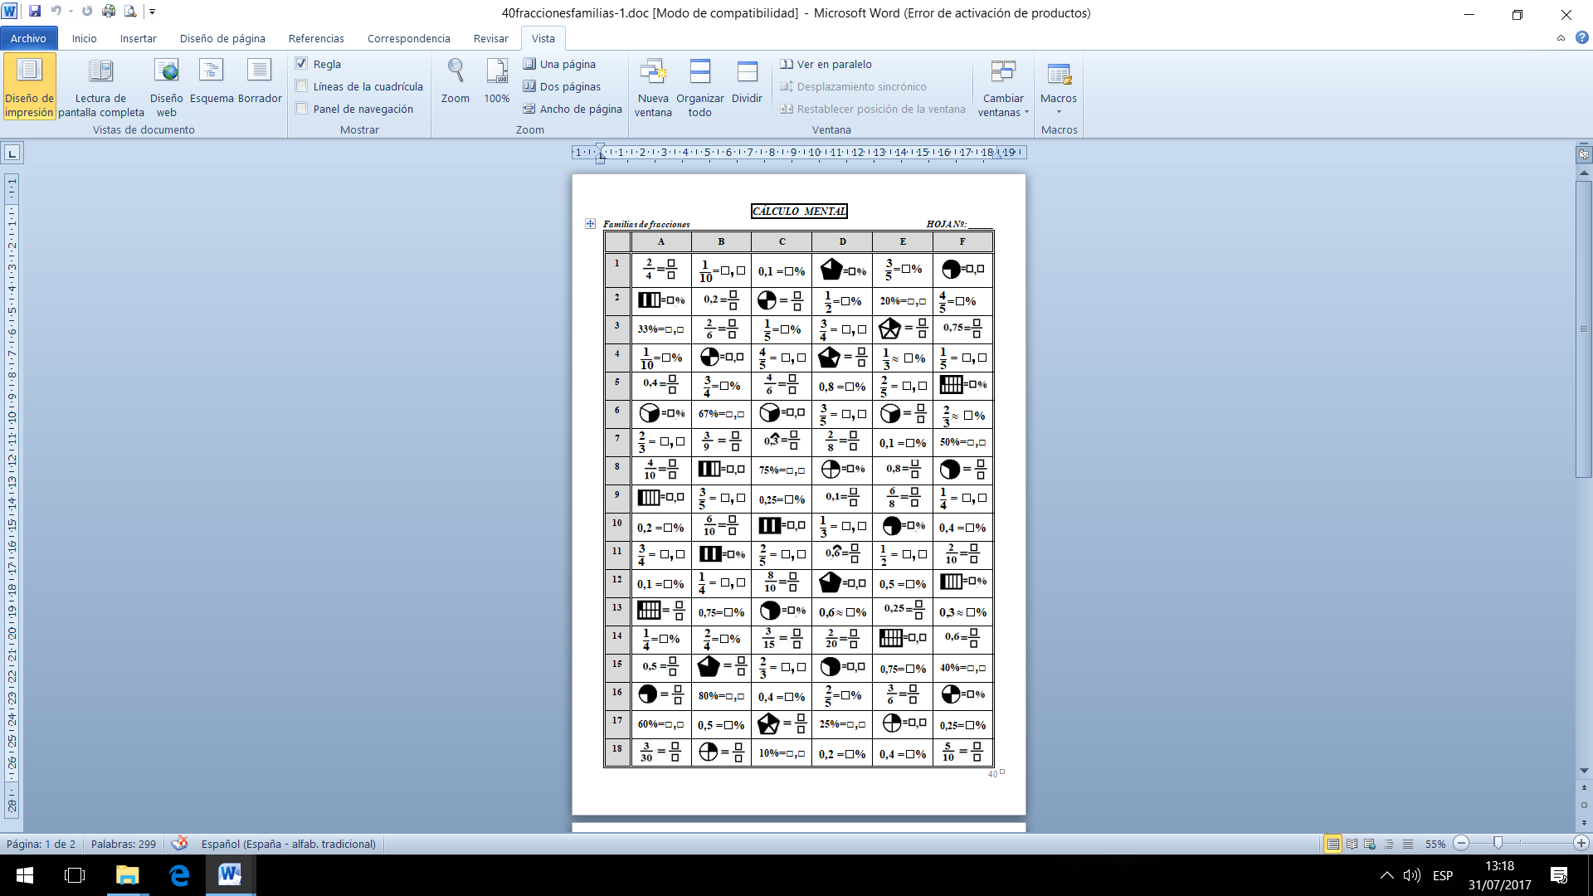

**HOJA DE RESPUESTAS**

***Familias de fracciones***

|  |  |  |  |  |  |  |
| --- | --- | --- | --- | --- | --- | --- |
|  | **A** | **B** | **C** | **D** | **E** | **F** |
| **1** |  |  |  |  |  |  |
| **2** |  |  |  |  |  |  |
| **3** |  |  |  |  |  |  |
| **4** |  |  |  |  |  |  |
| **5** |  |  |  |  |  |  |
| **6** |  |  |  |  |  |  |
| **7** |  |  |  |  |  |  |
| **8** |  |  |  |  |  |  |
| **9** |  |  |  |  |  |  |
| **10** |  |  |  |  |  |  |
| **11** |  |  |  |  |  |  |
| **12** |  |  |  |  |  |  |
| **13** |  |  |  |  |  |  |
| **14** |  |  |  |  |  |  |
| **15** |  |  |  |  |  |  |
| **16** |  |  |  |  |  |  |
| **17** |  |  |  |  |  |  |
| **18** |  |  |  |  |  |  |

**CÁLCULO MENTAL**

**SEGUNDO GRADO**

***Simplificar fracciones***

|  |  |  |  |  |  |  |  |
| --- | --- | --- | --- | --- | --- | --- | --- |
|  | **A** | **B** | **C** | **D** | **E** | **F** | **G** |
| **1** |  |  |  |  |  |  |  |
| **2** |  |  |  |  |  |  |  |
| **3** |  |  |  |  |  |  |  |
| **4** |  |  |  |  |  |  |  |
| **5** |  |  |  |  |  |  |  |
| **6** |  |  |  |  |  |  |  |
| **7** |  |  |  |  |  |  |  |
| **8** |  |  |  |  |  |  |  |
| **9** |  |  |  |  |  |  |  |
| **10** |  |  |  |  |  |  |  |
| **11** |  |  |  |  |  |  |  |
| **12** |  |  |  |  |  |  |  |
| **13** |  |  |  |  |  |  |  |
| **14** |  |  |  |  |  |  |  |
| **15** |  |  |  |  |  |  |  |
| **16** |  |  |  |  |  |  |  |
| **17** |  |  |  |  |  |  |  |
| **18** |  |  |  |  |  |  |  |

**HOJA DE RESPUESTAS**

***Simplificar fracciones***

|  |  |  |  |  |  |  |  |
| --- | --- | --- | --- | --- | --- | --- | --- |
|  | **A** | **B** | **C** | **D** | **E** | **F** | **G** |
| **1** |  |  |  |  |  |  |  |
| **2** |  |  |  |  |  |  |  |
| **3** |  |  |  |  |  |  |  |
| **4** |  |  |  |  |  |  |  |
| **5** |  |  |  |  |  |  |  |
| **6** |  |  |  |  |  |  |  |
| **7** |  |  |  |  |  |  |  |
| **8** |  |  |  |  |  |  |  |
| **9** |  |  |  |  |  |  |  |
| **10** |  |  |  |  |  |  |  |
| **11** |  |  |  |  |  |  |  |
| **12** |  |  |  |  |  |  |  |
| **13** |  |  |  |  |  |  |  |
| **14** |  |  |  |  |  |  |  |
| **15** |  |  |  |  |  |  |  |
| **16** |  |  |  |  |  |  |  |
| **17** |  |  |  |  |  |  |  |
| **18** |  |  |  |  |  |  |  |

**CÁLCULO MENTAL**

**SEGUNDO GRADO**

***Fracción como operador Página 63***

|  |  |  |  |  |  |  |
| --- | --- | --- | --- | --- | --- | --- |
|  | **A** | **B** | **C** | **D** | **E** | **F** |
| **1** | de 146 | 10% de  340 | La tercera parte de 12 | de 18 | 50% de  304 | de 20 |
| **2** | de | La mitad de un medio | 7 % de 600 | 4 % de 150 | de | La quinta parte de 35 |
| **3** | de 30 | de 24 | de 28 | La décima parte de 379 | 12 % de 200 | La mitad de 84,6 |
| **4** | de 28 | de 480 | de 530 | La tercera parte de 27 | de 60 | 25% de  300 |
| **5** | La quinta parte de 20 | de | La mitad de un tercio | 5 % de 500 | 6 % de 150 | de |
| **6** | La mitad de 72,4 | de 40 | de 32 | de 14 | La décima parte de 135 | 12 % de 300 |
| **7** | 25% de  400 | de 24 | de 246 | 10% de  270 | La tercera parte de 60 | de 15 |
| **8** | de | La quinta parte de 45 | de | La mitad de un cuarto | 3 % de 800 | 2 % de 250 |
| **9** | 12 % de 400 | La mitad de 68,2 | de 35 | de 16 | de 28 | La décima parte de 423 |
| **10** | de 21 | 25% de  500 | de 32 | de 310 | de 370 | La tercera parte de 90 |
| **11** | 2 % de 150 | de | La quinta parte de 15 | de | La mitad de un quinto | 9 % de 700 |
| **12** | La décima parte de 147 | 12 % de 500 | La mitad de 46,8 | de 45 | de 48 | de 42 |
| **13** | La tercera parte de 45 | de 24 | 25% de  600 | de 36 | de 262 | 10% de  670 |
| **14** | 50 % de 428 | 2 % de 250 | de | La quinta parte de 20 | de | La mitad de un sexto |
| **15** | de 49 | La décima parte de 231 | 13 % de 200 | La mitad de 84,6 | de 55 | de 56 |
| **16** | 10% de  260 | La tercera parte de 21 | de 33 | 50% de  422 | de 16 | de 428 |
| **17** | La mitad de un octavo | 50 % de 214 | 4 % de 250 | de | La quinta parte de 40 | de |
| **18** | de 72 | de 56 | La décima parte de 193 | 14 % de 200 | La mitad de 62,4 | de 35 |

**HOJA DE RESPUESTAS**

***Fracción como operador***

|  |  |  |  |  |  |  |
| --- | --- | --- | --- | --- | --- | --- |
|  | **A** | **B** | **C** | **D** | **E** | **F** |
| **1** |  |  |  |  |  |  |
| **2** |  |  |  |  |  |  |
| **3** |  |  |  |  |  |  |
| **4** |  |  |  |  |  |  |
| **5** |  |  |  |  |  |  |
| **6** |  |  |  |  |  |  |
| **7** |  |  |  |  |  |  |
| **8** |  |  |  |  |  |  |
| **9** |  |  |  |  |  |  |
| **10** |  |  |  |  |  |  |
| **11** |  |  |  |  |  |  |
| **12** |  |  |  |  |  |  |
| **13** |  |  |  |  |  |  |
| **14** |  |  |  |  |  |  |
| **15** |  |  |  |  |  |  |
| **16** |  |  |  |  |  |  |
| **17** |  |  |  |  |  |  |
| **18** |  |  |  |  |  |  |

**CÁLCULO MENTAL**

**SEGUNDO GRADO**

***Porcentajes 2***

|  |  |  |  |  |  |  |  |
| --- | --- | --- | --- | --- | --- | --- | --- |
| **↑10%=·1,10** | **↑25%=·1,25** | **↑50%=·1,50** | **↑100%= ·2** | **↓10%=·0,90** | **↓20%=·0,80** | **↓30%=·0,70** | **↓50%=·0,50** |

|  |  |  |  |  |  |  |
| --- | --- | --- | --- | --- | --- | --- |
|  | **A** | **B** | **C** | **D** | **E** | **F** |
| **1** | 20 ↑50% | 240 ↓50% | 30 ↓30% | 200 ↑25% | 70 ↓20% | 50 ↓10% |
| **2** | 10 ↓30% | 2000 ↑25% | 40 ↑50% | 7 ↑100% | 20 ↑10% | 800 ↑25% |
| **3** | 70 ↑10% | 30 ↑50% | 140 ↓50% | 160 ↓50% | 400 ↑25% | 10 ↑50% |
| **4** | 220 ↓50% | 70 ↓10% | 50 ↑10% | 50 ↑50% | 120 ↓50% | 60 ↓30% |
| **5** | 1000 ↑25% | 60 ↑10% | 100 ↑25% | 40 ↓30% | 60 ↑50% | 40 ↑10% |
| **6** | 90 ↓20% | 20 ↓30% | 6 ↑50% | 30 ↑10% | 30 ↓10% | 180 ↓50% |
| **7** | 2 ↑50% | 100 ↓20% | 20 ↓10% | 40 ↓10% | 50 ↓30% | 14 ↑50% |
| **8** | 60 ↓10% | 4 ↑50% | 21 ↑100% | 80 ↑25% | 12 ↑50% | 80 ↓20% |
| **9** | 14 ↑100% | 20 ↓20% | 4 ↑25% | 8 ↑50% | 40 ↓20% | 9 ↑100% |
| **10** | 28 ↓50% | 12 ↑100% | 200 ↓20% | 300 ↓20% | 13 ↑100% | 64 ↓50% |
| **11** | 600 ↑10% | 8 ↑25% | 100 ↑50% | 200 ↓10% | 40 ↑25% | 20 ↑25% |
| **12** | 400 ↓30% | 200 ↑50% | 42 ↓50% | 44 ↓50% | 62 ↓50% | 500 ↑10% |
| **13** | 300 ↑50% | 34 ↓50% | 200 ↑10% | 300 ↑10% | 500 ↑50% | 900 ↓30% |
| **14** | 12 ↑25% | 700 ↑10% | 600 ↓30% | 700 ↓30% | 300 ↓10% | 400 ↑50% |
| **15** | 10 ↓20% | 500 ↓30% | 30 ↓20% | 600 ↑50% | 400 ↑10% | 82 ↓50% |
| **16** | 500 ↓10% | 26 ↑50% | 25 ↑100% | 50 ↓20% | 84 ↓50% | 24 ↑25% |
| **17** | 44 ↑50% | 600 ↓10% | 700 ↓10% | 35 ↑100% | 45 ↑100% | 16 ↑50% |
| **18** | 16 ↓50% | 15 ↑100% | 24 ↑50% | 28 ↑25% | 16 ↑25% | 400 ↓10% |
| **19** | 44 ↑25% | 36 ↑25% | 22 ↓50% | 88 ↓50% | 18 ↑50% | 23 ↑100% |
| **20** | 5 ↑100% | 66 ↓50% | 32 ↑25% | 22 ↑50% | 800 ↓30% | 60 ↓20% |

**HOJA DE RESPUESTAS**

***Porcentajes 2***

|  |  |  |  |  |  |  |
| --- | --- | --- | --- | --- | --- | --- |
|  | **A** | **B** | **C** | **D** | **E** | **F** |
| **1** |  |  |  |  |  |  |
| **2** |  |  |  |  |  |  |
| **3** |  |  |  |  |  |  |
| **4** |  |  |  |  |  |  |
| **5** |  |  |  |  |  |  |
| **6** |  |  |  |  |  |  |
| **7** |  |  |  |  |  |  |
| **8** |  |  |  |  |  |  |
| **9** |  |  |  |  |  |  |
| **10** |  |  |  |  |  |  |
| **11** |  |  |  |  |  |  |
| **12** |  |  |  |  |  |  |
| **13** |  |  |  |  |  |  |
| **14** |  |  |  |  |  |  |
| **15** |  |  |  |  |  |  |
| **16** |  |  |  |  |  |  |
| **17** |  |  |  |  |  |  |
| **18** |  |  |  |  |  |  |
| **19** |  |  |  |  |  |  |
| **20** |  |  |  |  |  |  |

**CÁLCULO MENTAL**

**SEGUNDO GRADO**

***Lectura 1***

|  |  |  |  |  |  |  |
| --- | --- | --- | --- | --- | --- | --- |
|  | **A** | **B** | **C** | **D** | **E** | **F** |
| **1** | **El doble de 5** | **El doble de 70** | **El triple de 8** | **La tercera parte de 150** | **El doble de 22** | **La mitad de 24** |
| **2** | **El triple de 9** | **La tercera parte de 90** | **El doble de 7** | **El doble de 30** | **La tercera parte de 300** | **El triple de 10** |
| **3** | **La tercera parte de 75** | **El doble de 6** | **La tercera parte de600** | **La mitad de 18** | **El doble de 9** | **El doble de 21** |
| **4** | **El doble de 26** | **El triple de 15** | **El doble de 24** | **El doble de 8** | **El triple de 11** | **La tercera parte de 60** |
| **5** | **La mitad de 12** | **El doble de 25** | **La mitad de 16** | **El triple de 25** | **La mitad de 22** | **El doble de 4** |
| **6** | **El doble de 49** | **La mitad de 14** | **El doble de 47** | **El doble de 23** | **El doble de 38** | **La mitad de 68** |
| **7** | **La mitad de 66** | **El doble de 48** | **La mitad de 62** | **La mitad de 58** | **La mitad de 56** | **El doble de 37** |
| **8** | **El doble de 60** | **La mitad de 64** | **El doble de 40** | **El doble de 39** | **El doble de 50** | **La mitad de 50** |
| **9** | **El triple de 2** | **El doble de 14** | **El triple de 5** | **El triple de 4** | **La mitad de 60** | **El doble de 20** |
| **10** | **El doble de 15** | **El triple de 3** | **El doble de 13** | **La tercera parte de 9** | **El doble de 11** | **El triple de 7** |
| **11** | **La mitad de 36** | **La tercera parte de 15** | **La mitad de 20** | **La mitad de 28** | **El triple de 6** | **La tercera parte de 3** |
| **12** | **La tercera parte de 18** | **La mitad de 34** | **La tercera parte de 12** | **El doble de 12** | **La tercera parte de 6** | **La mitad de 38** |
| **13** | **El doble de 42** | **El doble de 41** | **El doble de 46** | **La mitad de 70** | **La mitad de 26** | **El doble de 16** |
| **14** | **La mitad de 40** | **La mitad de 30** | **La mitad de 32** | **El doble de 44** | **El doble de 45** | **El triple de 60** |
| **15** | **El doble de 33** | **El doble de 32** | **La tercera parte de 24** | **El triple de 30** | **El triple de 80** | **El doble de 43** |
| **16** | **El triple de 70** | **El triple de 50** | **El doble de 31** | **El doble de 17** | **El doble de 29** | **La mitad de 46** |
| **17** | **El doble de 27** | **La tercera parte de 27** | **La mitad de 54** | **La tercera parte de 30** | **La tercera parte de 45** | **El doble de 35** |
| **18** | **La mitad de 44** | **La mitad de 42** | **El doble de 18** | **El doble de 36** | **La mitad de 48** | **La tercera parte de 33** |
| **19** | **La tercera parte de 21** | **El doble de 19** | **El triple de 40** | **La mitad de 52** | **El doble de 34** | **El doble de 28** |

**HOJA DE RESPUESTAS**

***Lectura 1***

|  |  |  |  |  |  |  |
| --- | --- | --- | --- | --- | --- | --- |
|  | **A** | **B** | **C** | **D** | **E** | **F** |
| **1** |  |  |  |  |  |  |
| **2** |  |  |  |  |  |  |
| **3** |  |  |  |  |  |  |
| **4** |  |  |  |  |  |  |
| **5** |  |  |  |  |  |  |
| **6** |  |  |  |  |  |  |
| **7** |  |  |  |  |  |  |
| **8** |  |  |  |  |  |  |
| **9** |  |  |  |  |  |  |
| **10** |  |  |  |  |  |  |
| **11** |  |  |  |  |  |  |
| **12** |  |  |  |  |  |  |
| **13** |  |  |  |  |  |  |
| **14** |  |  |  |  |  |  |
| **15** |  |  |  |  |  |  |
| **16** |  |  |  |  |  |  |
| **17** |  |  |  |  |  |  |
| **18** |  |  |  |  |  |  |
| **19** |  |  |  |  |  |  |

**CÁLCULO MENTAL**

**SEGUNDO GRADO**

***Monomios 1 ( + , - , · )***

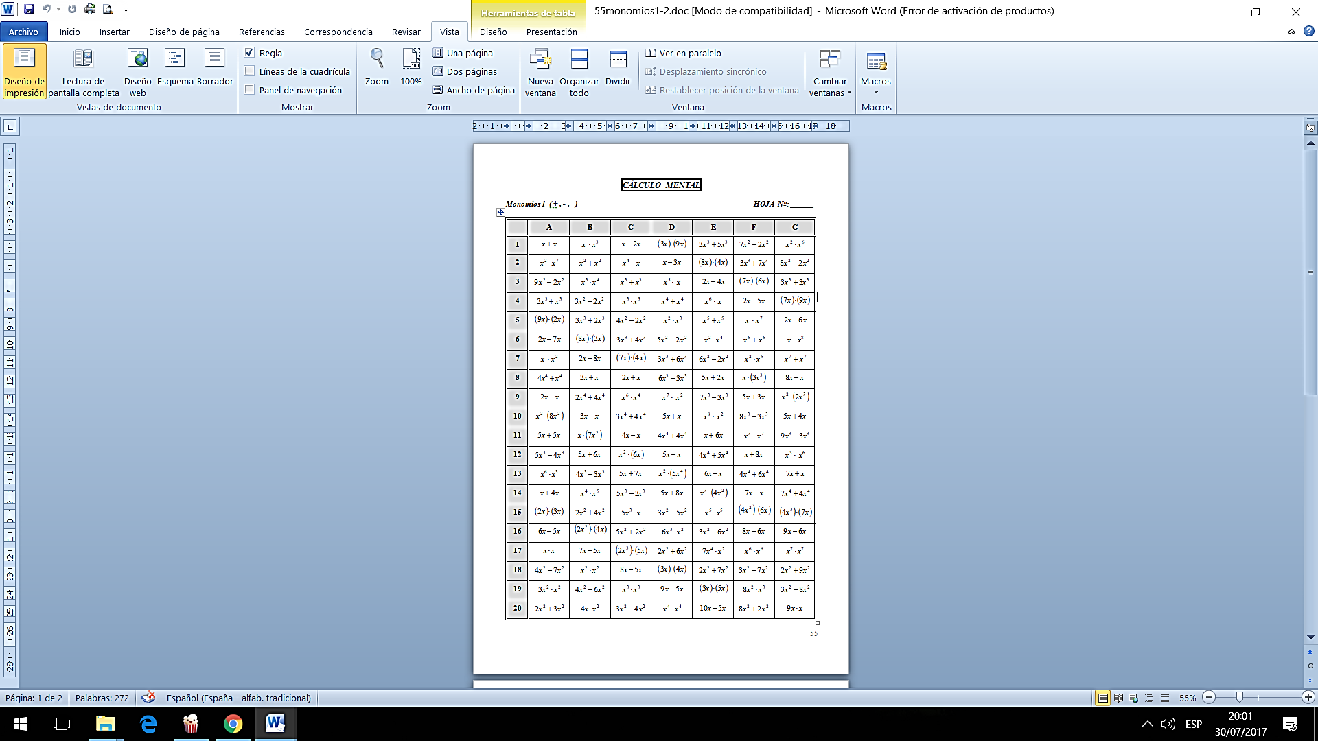

**HOJA DE RESPUESTAS**

***Monomios 1 ( + , - , · )***

|  |  |  |  |  |  |  |  |
| --- | --- | --- | --- | --- | --- | --- | --- |
|  | **A** | **B** | **C** | **D** | **E** | **F** | **G** |
| **1** |  |  |  |  |  |  |  |
| **2** |  |  |  |  |  |  |  |
| **3** |  |  |  |  |  |  |  |
| **4** |  |  |  |  |  |  |  |
| **5** |  |  |  |  |  |  |  |
| **6** |  |  |  |  |  |  |  |
| **7** |  |  |  |  |  |  |  |
| **8** |  |  |  |  |  |  |  |
| **9** |  |  |  |  |  |  |  |
| **10** |  |  |  |  |  |  |  |
| **11** |  |  |  |  |  |  |  |
| **12** |  |  |  |  |  |  |  |
| **13** |  |  |  |  |  |  |  |
| **14** |  |  |  |  |  |  |  |
| **15** |  |  |  |  |  |  |  |
| **16** |  |  |  |  |  |  |  |
| **17** |  |  |  |  |  |  |  |
| **18** |  |  |  |  |  |  |  |
| **19** |  |  |  |  |  |  |  |
| **20** |  |  |  |  |  |  |  |

**CÁLCULO MENTAL**

**SEGUNDO GRADO**

***Monomios 2 ( + , - , ·, / )***

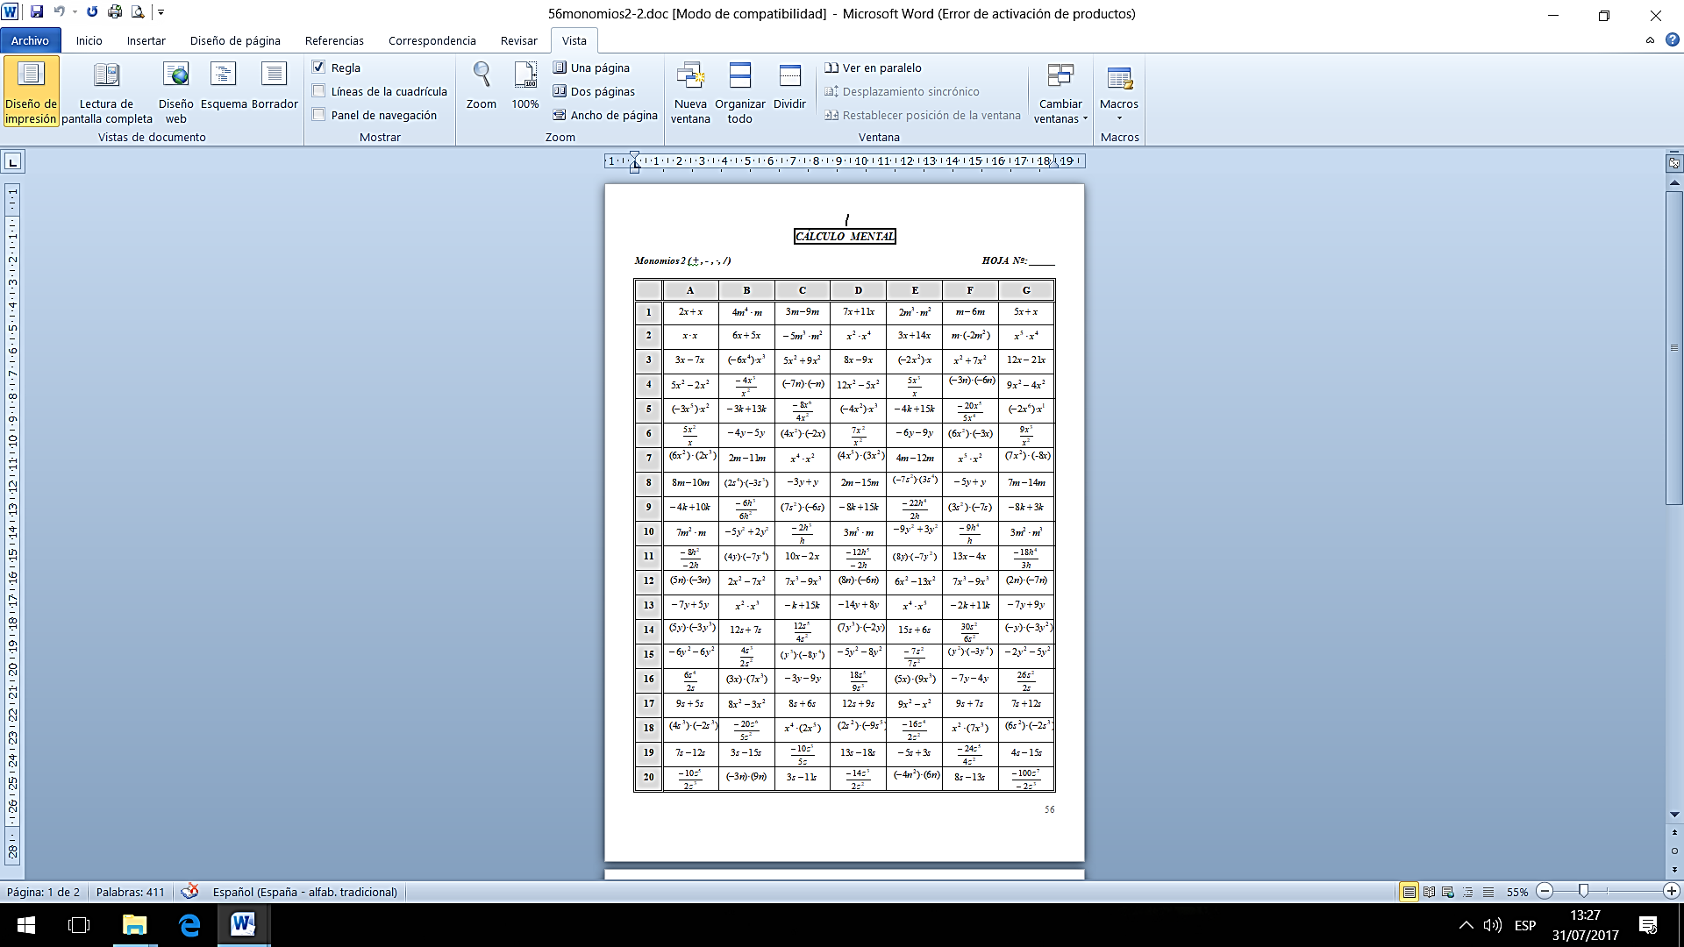

**HOJA DE RESPUESTAS**

***Monomios 2 ( + , - , ·, / )***

|  |  |  |  |  |  |  |  |
| --- | --- | --- | --- | --- | --- | --- | --- |
|  | **A** | **B** | **C** | **D** | **E** | **F** | **G** |
| **1** |  |  |  |  |  |  |  |
| **2** |  |  |  |  |  |  |  |
| **3** |  |  |  |  |  |  |  |
| **4** |  |  |  |  |  |  |  |
| **5** |  |  |  |  |  |  |  |
| **6** |  |  |  |  |  |  |  |
| **7** |  |  |  |  |  |  |  |
| **8** |  |  |  |  |  |  |  |
| **9** |  |  |  |  |  |  |  |
| **10** |  |  |  |  |  |  |  |
| **11** |  |  |  |  |  |  |  |
| **12** |  |  |  |  |  |  |  |
| **13** |  |  |  |  |  |  |  |
| **14** |  |  |  |  |  |  |  |
| **15** |  |  |  |  |  |  |  |
| **16** |  |  |  |  |  |  |  |
| **17** |  |  |  |  |  |  |  |
| **18** |  |  |  |  |  |  |  |
| **19** |  |  |  |  |  |  |  |
| **20** |  |  |  |  |  |  |  |

**CÁLCULO MENTAL**

**SEGUNDO GRADO**

***Valor numérico (expresiones algebraicas)***

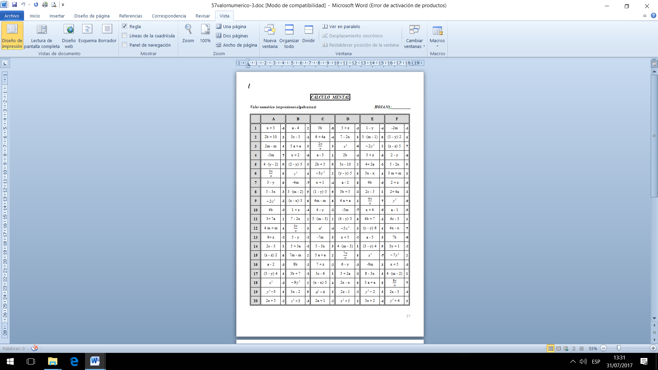

**HOJA DE RESPUESTAS**

***Valor numérico (expresiones algebraicas)***

|  |  |  |  |  |  |  |  |
| --- | --- | --- | --- | --- | --- | --- | --- |
|  | **A** | **B** | **C** | **D** | **E** | **F** | **G** |
| **1** |  |  |  |  |  |  |  |
| **2** |  |  |  |  |  |  |  |
| **3** |  |  |  |  |  |  |  |
| **4** |  |  |  |  |  |  |  |
| **5** |  |  |  |  |  |  |  |
| **6** |  |  |  |  |  |  |  |
| **7** |  |  |  |  |  |  |  |
| **8** |  |  |  |  |  |  |  |
| **9** |  |  |  |  |  |  |  |
| **10** |  |  |  |  |  |  |  |
| **11** |  |  |  |  |  |  |  |
| **12** |  |  |  |  |  |  |  |
| **13** |  |  |  |  |  |  |  |
| **14** |  |  |  |  |  |  |  |
| **15** |  |  |  |  |  |  |  |
| **16** |  |  |  |  |  |  |  |
| **17** |  |  |  |  |  |  |  |
| **18** |  |  |  |  |  |  |  |
| **19** |  |  |  |  |  |  |  |
| **20** |  |  |  |  |  |  |  |

**CÁLCULO MENTAL**

**SEGUNDO GRADO**

***Ecuaciones 1***

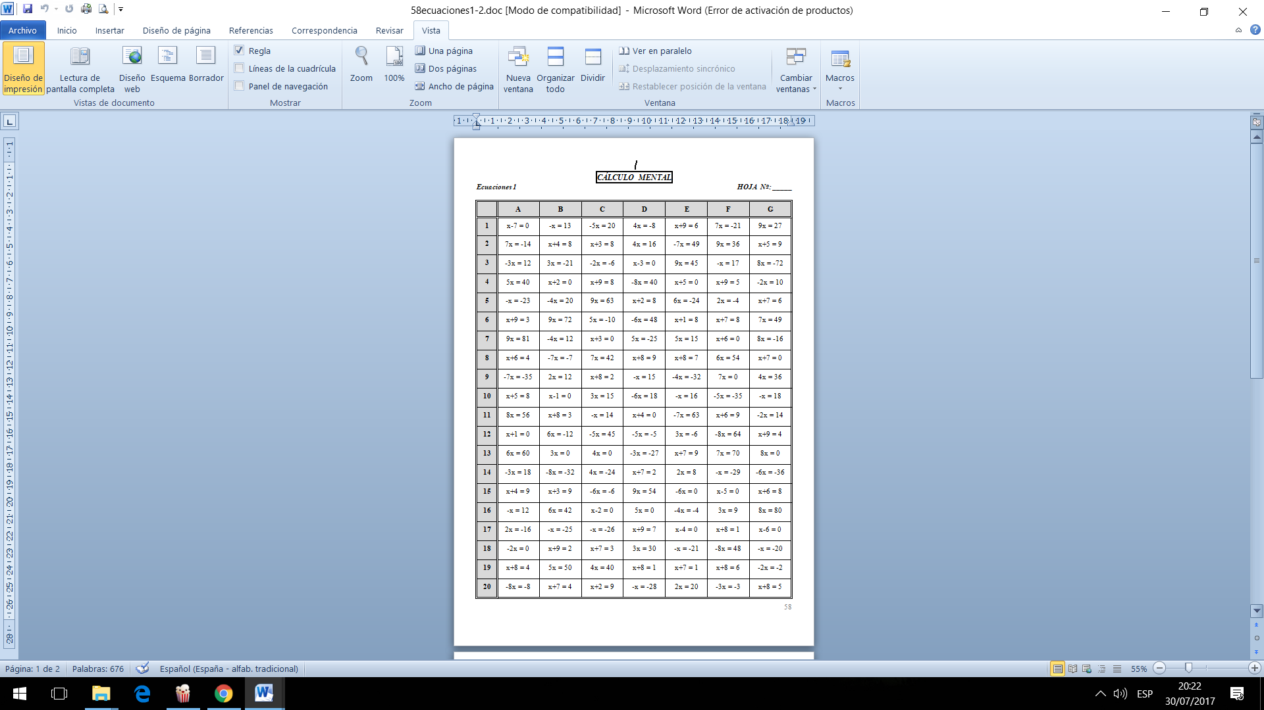

**HOJA DE RESPUESTAS**

***Ecuaciones 1***

|  |  |  |  |  |  |  |  |
| --- | --- | --- | --- | --- | --- | --- | --- |
|  | **A** | **B** | **C** | **D** | **E** | **F** | **G** |
| **1** |  |  |  |  |  |  |  |
| **2** |  |  |  |  |  |  |  |
| **3** |  |  |  |  |  |  |  |
| **4** |  |  |  |  |  |  |  |
| **5** |  |  |  |  |  |  |  |
| **6** |  |  |  |  |  |  |  |
| **7** |  |  |  |  |  |  |  |
| **8** |  |  |  |  |  |  |  |
| **9** |  |  |  |  |  |  |  |
| **10** |  |  |  |  |  |  |  |
| **11** |  |  |  |  |  |  |  |
| **12** |  |  |  |  |  |  |  |
| **13** |  |  |  |  |  |  |  |
| **14** |  |  |  |  |  |  |  |
| **15** |  |  |  |  |  |  |  |
| **16** |  |  |  |  |  |  |  |
| **17** |  |  |  |  |  |  |  |
| **18** |  |  |  |  |  |  |  |
| **19** |  |  |  |  |  |  |  |
| **20** |  |  |  |  |  |  |  |

**CÁLCULO MENTAL**

**SEGUNDO GRADO**

***Ecuaciones 2***

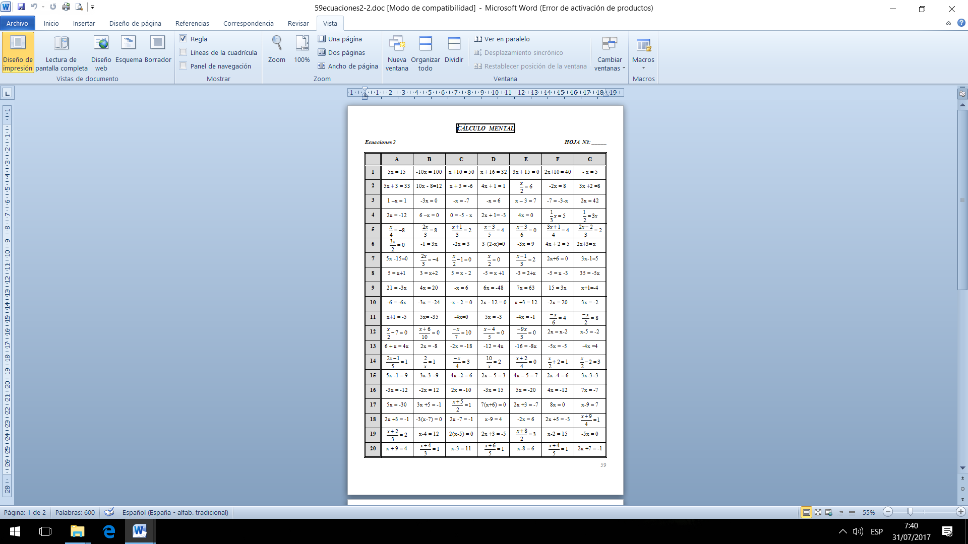

**HOJA DE RESPUESTAS**

***Ecuaciones 2***

|  |  |  |  |  |  |  |  |
| --- | --- | --- | --- | --- | --- | --- | --- |
|  | **A** | **B** | **C** | **D** | **E** | **F** | **G** |
| **1** |  |  |  |  |  |  |  |
| **2** |  |  |  |  |  |  |  |
| **3** |  |  |  |  |  |  |  |
| **4** |  |  |  |  |  |  |  |
| **5** |  |  |  |  |  |  |  |
| **6** |  |  |  |  |  |  |  |
| **7** |  |  |  |  |  |  |  |
| **8** |  |  |  |  |  |  |  |
| **9** |  |  |  |  |  |  |  |
| **10** |  |  |  |  |  |  |  |
| **11** |  |  |  |  |  |  |  |
| **12** |  |  |  |  |  |  |  |
| **13** |  |  |  |  |  |  |  |
| **14** |  |  |  |  |  |  |  |
| **15** |  |  |  |  |  |  |  |
| **16** |  |  |  |  |  |  |  |
| **17** |  |  |  |  |  |  |  |
| **18** |  |  |  |  |  |  |  |
| **19** |  |  |  |  |  |  |  |
| **20** |  |  |  |  |  |  |  |

**CÁLCULO MENTAL**

**SEGUNDO GRADO**

***Perímetro***

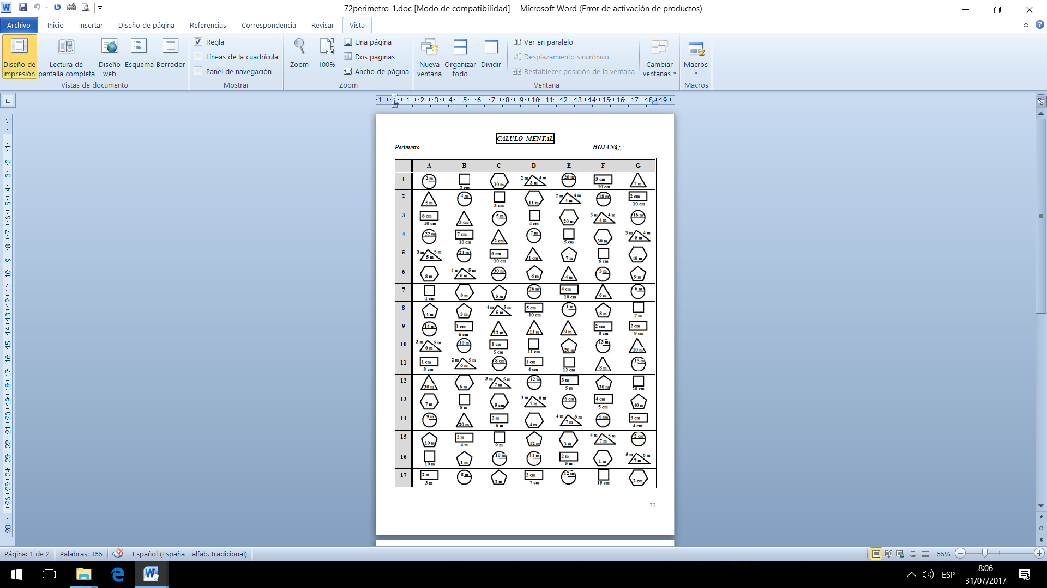

**HOJA DE RESPUESTAS**

***Perímetro***

|  |  |  |  |  |  |  |  |
| --- | --- | --- | --- | --- | --- | --- | --- |
|  | **A** | **B** | **C** | **D** | **E** | **F** | **G** |
| **1** |  |  |  |  |  |  |  |
| **2** |  |  |  |  |  |  |  |
| **3** |  |  |  |  |  |  |  |
| **4** |  |  |  |  |  |  |  |
| **5** |  |  |  |  |  |  |  |
| **6** |  |  |  |  |  |  |  |
| **7** |  |  |  |  |  |  |  |
| **8** |  |  |  |  |  |  |  |
| **9** |  |  |  |  |  |  |  |
| **10** |  |  |  |  |  |  |  |
| **11** |  |  |  |  |  |  |  |
| **12** |  |  |  |  |  |  |  |
| **13** |  |  |  |  |  |  |  |
| **14** |  |  |  |  |  |  |  |
| **15** |  |  |  |  |  |  |  |
| **16** |  |  |  |  |  |  |  |
| **17** |  |  |  |  |  |  |  |

**CÁLCULO MENTAL**

**SEGUNDO GRADO**

***Área y Perímetro:*** ***()***

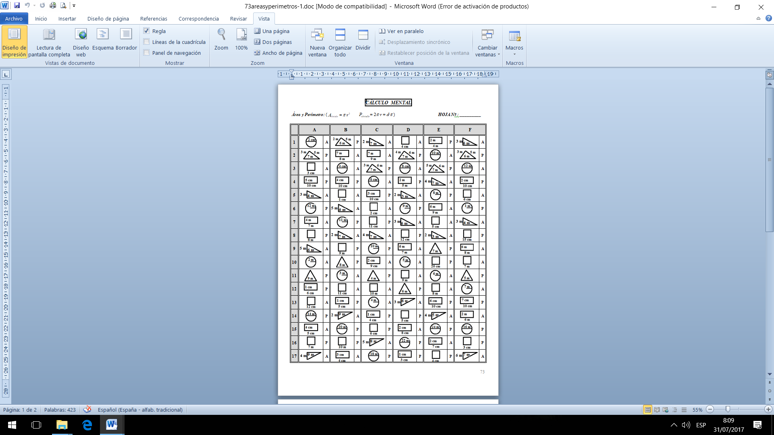

**HOJA DE RESPUESTAS**

***Área y Perímetro:*** ***()***

|  |  |  |  |  |  |  |
| --- | --- | --- | --- | --- | --- | --- |
|  | **A** | **B** | **C** | **D** | **E** | **F** |
| **1** |  |  |  |  |  |  |
| **2** |  |  |  |  |  |  |
| **3** |  |  |  |  |  |  |
| **4** |  |  |  |  |  |  |
| **5** |  |  |  |  |  |  |
| **6** |  |  |  |  |  |  |
| **7** |  |  |  |  |  |  |
| **8** |  |  |  |  |  |  |
| **9** |  |  |  |  |  |  |
| **10** |  |  |  |  |  |  |
| **11** |  |  |  |  |  |  |
| **12** |  |  |  |  |  |  |
| **13** |  |  |  |  |  |  |
| **14** |  |  |  |  |  |  |
| **15** |  |  |  |  |  |  |
| **16** |  |  |  |  |  |  |
| **17** |  |  |  |  |  |  |

**CÁLCULO MENTAL**

**SEGUNDO GRADO**

***Unidades de longitud (Conversiones)***

|  |  |  |  |  |  |  |
| --- | --- | --- | --- | --- | --- | --- |
|  | **A** | **B** | **C** | **D** | **E** | **F** |
| **1** | **5 km = …m** | **80 cm = …m** | **0.8 km = …m** | **650 cm = …m** | **3.2 km = …m** | **300 cm = …m** |
| **2** | **350 cm = …m** | **4.3 m = …dm** | **35 cm = …m** | **0.5 m = …dm** | **100 cm = …m** | **3 m = …dm** |
| **3** | **415 dm = …m** | **8.2 m = …cm** | **415 dm = …m** | **7 m = …cm** | **85 dm = …m** | **2.1 m = …cm** |
| **4** | **2 hm = … m** | **34 cm = …dm** | **0.6 m = … dm** | **42 cm = …dm** | **5 hm = … m** | **50 cm = …dm** |
| **5** | **3 dam = …m** | **6.1 hm = …m** | **0.05m = …cm** | **0.7 hm = …m** | **4 dam = …m** | **4 hm = …m** |
| **6** | **900 mm=…m** | **250 m = …km** | **930 m = …km** | **5400 m=…km** | **450 mm=…m** | **8600m=…km** |
| **7** | **2.3 km = …m** | **5 km = …m** | **3200 m=…km** | **5.6 km = …m** | **7.2 km = …m** | **8 km =…m** |
| **8** | **35 dm = …m** | **60 dm = …m** | **2.5 km = …m** | **48 dm = …m** | **70 dm = …m** | **60 dm = …m** |
| **9** | **0.45m = …cm** | **1.2 m = …cm** | **7 m = …cm** | **0.85m = …cm** | **5 m = …cm** | **0.4 m = …cm** |
| **10** | **3 hm = …m** | **4 hm = …m** | **850mm= …m** | **9 hm = …m** | **2 hm = …m** | **9 hm = …m** |
| **11** | **4 dam = …m** | **2.1 dam = .m** | **7 hm = …m** | **5 dam = …m** | **3 dam = …m** | **6 dam = …m** |
| **12** | **2 km = …m** | **9 km = …m** | **4 dam = …m** | **3 km = …m** | **8 km = …m** | **1 km = …m** |
| **13** | **2500m= …km** | **500m = … km** | **3.7 km = …m** | **4000m=… km** | **7300m=…km** | **6500m=…km** |
| **14** | **0.7 km = …m** | **1. 2 km = …m** | **9.4 km = …m** | **8 km = …m** | **6.5 km = …m** | **9. 2 km = …m** |
| **15** | **34 dm = …m** | **5 dam = …m** | **8 dam = …m** | **3 dam = …m** | **9 dam = …m** | **2.5 dam=…m** |
| **16** | **400 cm = …m** | **200 cm = …m** | **4500 cm=…m** | **50 cm = …m** | **7000 cm=…m** | **4300 cm=…m** |
| **17** | **0.3 m = … dm** | **6 m = … dm** | **45 m = … dm** | **2 m = … dm** | **8 m = … dm** | **9 m = … dm** |
| **18** | **450 mm=…m** | **300 mm=…m** | **420 dm = …m** | **4800 m=…m** | **900 mm=…m** | **5000mm=…m** |
| **19** | **1.3 m = … cm** | **9 m = … cm** | **5.7 m = … cm** | **6 m = … cm** | **9 m = … cm** | **1.5 m = … cm** |
| **20** | **8.3 km = …m** | **0.5 km = …m** | **2.5 km = …m** | **6 km = …m** | **3.5 km = …m** | **4.2 km = …m** |

**HOJA DE RESPUESTAS**

***Unidades de longitud (Conversiones)***

|  |  |  |  |  |  |  |
| --- | --- | --- | --- | --- | --- | --- |
|  | **A** | **B** | **C** | **D** | **E** | **F** |
| **1** |  |  |  |  |  |  |
| **2** |  |  |  |  |  |  |
| **3** |  |  |  |  |  |  |
| **4** |  |  |  |  |  |  |
| **5** |  |  |  |  |  |  |
| **6** |  |  |  |  |  |  |
| **7** |  |  |  |  |  |  |
| **8** |  |  |  |  |  |  |
| **9** |  |  |  |  |  |  |
| **10** |  |  |  |  |  |  |
| **11** |  |  |  |  |  |  |
| **12** |  |  |  |  |  |  |
| **13** |  |  |  |  |  |  |
| **14** |  |  |  |  |  |  |
| **15** |  |  |  |  |  |  |
| **16** |  |  |  |  |  |  |
| **17** |  |  |  |  |  |  |
| **18** |  |  |  |  |  |  |
| **19** |  |  |  |  |  |  |
| **20** |  |  |  |  |  |  |

**CÁLCULO MENTAL**

**SEGUNDO GRADO**

***Unidades de capacidad (conversiones)***

|  |  |  |  |  |  |  |
| --- | --- | --- | --- | --- | --- | --- |
|  | **A** | **B** | **C** | **D** | **E** | **F** |
| **1** | **6 kl = …l** | **70 cl = …l** | **0. 8 kl = …l** | **350 cl = …l** | **2.3 kl = …l** | **400 cl = …l** |
| **2** | **250 cl = …l** | **3.4 l = …dl** | **65 cl = …l** | **0.5 l = …dl** | **100 cl = …l** | **3 l = …dl** |
| **3** | **175 dl = …l** | **6.2 l = …cl** | **715 dl = …l** | **8 l = …cl** | **95 dl = …l** | **1.2 l = …cl** |
| **4** | **3 hl = … l** | **36 cl = …dl** | **0.3 l = … dl** | **42 cl = …dl** | **5 hl = … dal** | **50 cl = …dl** |
| **5** | **2 dal = …l** | **5.1 hl = …l** | **0.05 l = …cl** | **0. 9 hl = …l** | **8 dal = …l** | **4 hl = …l** |
| **6** | **7 ml = …cl** | **350 l = …kl** | **940 l = …kl** | **7400 l = …kl** | **650 ml = …l** | **8600 l = …kl** |
| **7** | **2.4 kl = …l** | **4 kl = …l** | **3200 hl = …kl** | **5.6 kl = …l** | **4.2 kl = …l** | **8 kl =…l** |
| **8** | **2.3 l = … cl** | **8 ml = … cl** | **6.7 l = … cl** | **5 l = … cl** | **8 l = … cl** | **3.5 l = … cl** |
| **9** | **25 dl = …l** | **30 dl = …l** | **2.5 kl = …l** | **43 dl = …l** | **70 dl = …l** | **60 dl = …l** |
| **10** | **450 ml = …l** | **600 ml = …l** | **420 dl = …l** | **280 ml = …cl** | **900 ml = …l** | **5000 ml = …l** |
| **11** | **0.45 l = …cl** | **1.2 l = …cl** | **90 ml = …cl** | **0.85 l = …cl** | **5 l = …cl** | **0.7 l = …cl** |
| **12** | **8 dal = …l** | **2.1 dal = …l** | **7 hl = …l** | **5 dal = …l** | **2 dal = …l** | **6 dal = …l** |
| **13** | **3 kl = …l** | **9 kl = …l** | **4 dal = …l** | **3 kl = …l** | **8 kl = …dal** | **1 kl = …hl** |
| **14** | **1500 l = … kl** | **500 l = … kl** | **3.7 kl = …dal** | **4000 l = … kl** | **7300 l = … kl** | **6500 l = … kl** |
| **15** | **0.6 kl = …dal** | **1.2 kl = …dal** | **9.4 kl = …l** | **8.1 hl = …l** | **0.65 kl = …l** | **9.2 kl = …hl** |
| **16** | **24 dl = …l** | **3 dal = …l** | **5 dal = …l** | **4 dal = …l** | **9 dal = …l** | **2.5 dal = …l** |
| **17** | **400 cl = …dl** | **500 cl = …l** | **2500 cl = …l** | **20 cl = …l** | **700 ml = …cl** | **4300 cl = …l** |
| **18** | **0.3 l = … dl** | **6 l = … dl** | **45 l = … dl** | **5 l = … dl** | **98 l = … dl** | **6 l = … dl** |
| **19** | **7 hl = …l** | **5 hl = …l** | **850 ml = …l** | **9 hl = …dal** | **3 hl = …l** | **9 hl = …l** |

**HOJA DE RESPUESTAS**

***Unidades de capacidad (conversiones)***

|  |  |  |  |  |  |  |
| --- | --- | --- | --- | --- | --- | --- |
|  | **A** | **B** | **C** | **D** | **E** | **F** |
| **1** |  |  |  |  |  |  |
| **2** |  |  |  |  |  |  |
| **3** |  |  |  |  |  |  |
| **4** |  |  |  |  |  |  |
| **5** |  |  |  |  |  |  |
| **6** |  |  |  |  |  |  |
| **7** |  |  |  |  |  |  |
| **8** |  |  |  |  |  |  |
| **9** |  |  |  |  |  |  |
| **10** |  |  |  |  |  |  |
| **11** |  |  |  |  |  |  |
| **12** |  |  |  |  |  |  |
| **13** |  |  |  |  |  |  |
| **14** |  |  |  |  |  |  |
| **15** |  |  |  |  |  |  |
| **16** |  |  |  |  |  |  |
| **17** |  |  |  |  |  |  |
| **18** |  |  |  |  |  |  |
| **19** |  |  |  |  |  |  |

**CÁLCULO MENTAL**

**SEGUNDO GRADO**

***Unidades de masa (conversiones)***

|  |  |  |  |  |  |  |
| --- | --- | --- | --- | --- | --- | --- |
|  | **A** | **B** | **C** | **D** | **E** | **F** |
| **1** | **7 kg = …g** | **76 cg = …g** | **1. 9 kg = …g** | **450 cg = …g** | **2.4 kg = …g** | **300 cg = …g** |
| **2** | **450 cg = …g** | **3.2 g = …dg** | **75 cg = …g** | **0.6 g = …dg** | **500 cg = …g** | **2 g = …dg** |
| **3** | **375 dg = …g** | **6.1 g = …cg** | **925 kg=…tm** | **7 g = …cg** | **85 dg = …g** | **1.9 g = …cg** |
| **4** | **850 kg = … tm** | **730kg =…tm** | **0.3 g = … dg** | **5400kg=…tm** | **6200kg=…tm** | **780 kg=…tm** |
| **5** | **3 dag = …g** | **2.6 hg = …g** | **0.04 g = …cg** | **0. 8 hg = …g** | **4 dag = …g** | **7 hg = …g** |
| **6** | **600 mg = …g** | **350 g = …kg** | **940 g = …kg** | **7400 g = …kg** | **650 mg = …g** | **8600g = …kg** |
| **7** | **3.4 kg = …g** | **4 kg = …g** | **0.8 tm =…kg** | **4.3 kg = …g** | **5.2 tm = …kg** | **8 tm =…kg** |
| **8** | **2.7 g = … cg** | **0.8 tm=… kg** | **6.7 g = … cg** | **6 g = … cg** | **7 g = … cg** | **3.5 g = … cg** |
| **9** | **6.2 tm= …kg** | **30 dg = …g** | **2.5 kg = …g** | **53 dg = …g** | **80 dg = …g** | **50 dg = …g** |
| **10** | **540 mg= …g** | **600 mg = …g** | **420 dg = …g** | **2.9 tm = …kg** | **900 mg = …g** | **6000mg=…g** |
| **11** | **0.75 g = …cg** | **1.2 g = …cg** | **700 kg=…tm** | **0.85 g = …cg** | **5 g = …cg** | **0.7 g = …cg** |
| **12** | **4 dag = …g** | **3.1 dag = …g** | **8 hg = …g** | **500g =… dag** | **2 dag = …g** | **4 dag = …g** |
| **13** | **8 tm = …kg** | **9 kg = …g** | **3 dag = …g** | **3 kg = …g** | **8 tm = …kg** | **2 kg = …hg** |
| **14** | **3500 g=… kg** | **500 g = … kg** | **4700g= …kg** | **4000g = … kg** | **7300g = … kg** | **9500g =… kg** |
| **15** | **0.3 g=…dag** | **3200kg=…tm** | **9.5tm = …kg** | **8.1 tm = …kg** | **0.65 kg = …g** | **8.2tm = …kg** |
| **16** | **64 dg = …g** | **4 dag = …g** | **6 dag = …g** | **3 dag = …g** | **3 dag = …g** | **4.5 dag = …g** |
| **17** | **200cg = …dg** | **600 cg = …g** | **3500cg = …g** | **40 cg = …g** | **700kg = …tm** | **6300kg=…tm** |
| **18** | **4500kg= tm** | **5 tm = … kg** | **75 g = … dg** | **6 g = … dg** | **98 g = … dg** | **9 g = … dg** |
| **19** | **7 hg = …g** | **7 hg = …g** | **450mg = …g** | **7200kg=…tm** | **4 hg = …g** | **3 hg = …g** |
| **20** | **6.3 kg = …g** | **4.5 kg = …g** | **0.5 kg = …g** | **8 kg = …g** | **6.5 kg = …g** | **7.1 kg = …g** |

**HOJA DE RESPUESTAS**

***Unidades de masa (conversiones)***

|  |  |  |  |  |  |  |
| --- | --- | --- | --- | --- | --- | --- |
|  | **A** | **B** | **C** | **D** | **E** | **F** |
| **1** |  |  |  |  |  |  |
| **2** |  |  |  |  |  |  |
| **3** |  |  |  |  |  |  |
| **4** |  |  |  |  |  |  |
| **5** |  |  |  |  |  |  |
| **6** |  |  |  |  |  |  |
| **7** |  |  |  |  |  |  |
| **8** |  |  |  |  |  |  |
| **9** |  |  |  |  |  |  |
| **10** |  |  |  |  |  |  |
| **11** |  |  |  |  |  |  |
| **12** |  |  |  |  |  |  |
| **13** |  |  |  |  |  |  |
| **14** |  |  |  |  |  |  |
| **15** |  |  |  |  |  |  |
| **16** |  |  |  |  |  |  |
| **17** |  |  |  |  |  |  |
| **18** |  |  |  |  |  |  |
| **19** |  |  |  |  |  |  |
| **20** |  |  |  |  |  |  |

**CÁLCULO MENTAL**

**SEGUNDO GRADO**

***Potencias 1***

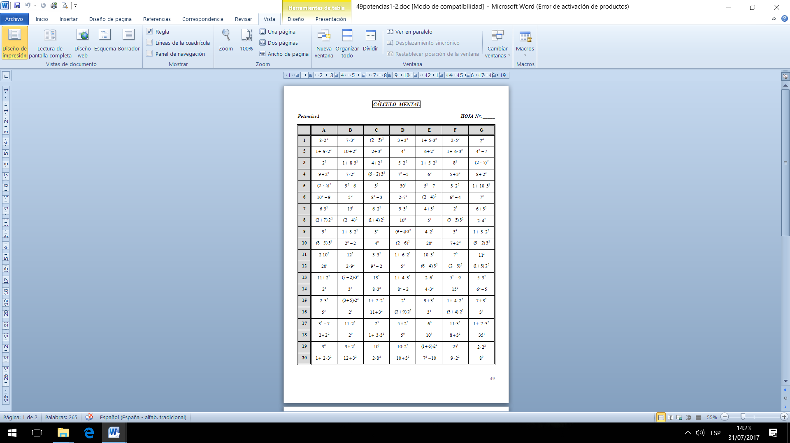

**HOJA DE RESPUESTAS**

***Potencias 1***

|  |  |  |  |  |  |  |  |
| --- | --- | --- | --- | --- | --- | --- | --- |
|  | **A** | **B** | **C** | **D** | **E** | **F** | **G** |
| **1** |  |  |  |  |  |  |  |
| **2** |  |  |  |  |  |  |  |
| **3** |  |  |  |  |  |  |  |
| **4** |  |  |  |  |  |  |  |
| **5** |  |  |  |  |  |  |  |
| **6** |  |  |  |  |  |  |  |
| **7** |  |  |  |  |  |  |  |
| **8** |  |  |  |  |  |  |  |
| **9** |  |  |  |  |  |  |  |
| **10** |  |  |  |  |  |  |  |
| **11** |  |  |  |  |  |  |  |
| **12** |  |  |  |  |  |  |  |
| **13** |  |  |  |  |  |  |  |
| **14** |  |  |  |  |  |  |  |
| **15** |  |  |  |  |  |  |  |
| **16** |  |  |  |  |  |  |  |
| **17** |  |  |  |  |  |  |  |
| **18** |  |  |  |  |  |  |  |
| **19** |  |  |  |  |  |  |  |
| **20** |  |  |  |  |  |  |  |

**CÁLCULO MENTAL**

**SEGUNDO GRADO**

***Potencias 2***

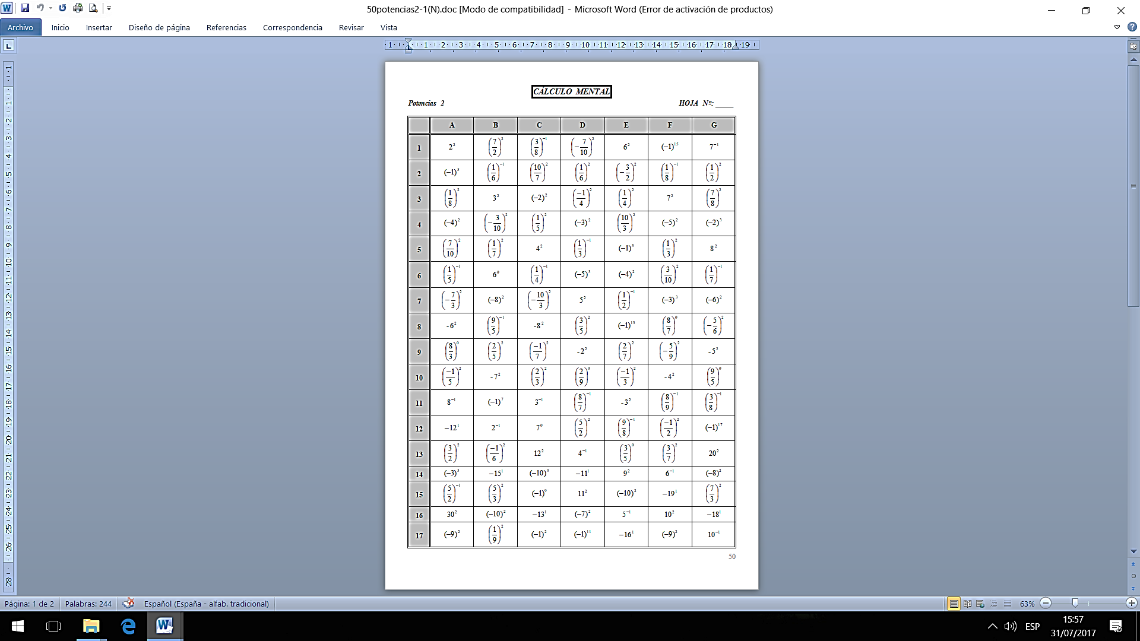

**HOJA DE RESPUESTAS**

***Potencias 2***

|  |  |  |  |  |  |  |  |
| --- | --- | --- | --- | --- | --- | --- | --- |
|  | **A** | **B** | **C** | **D** | **E** | **F** | **G** |
| **1** |  |  |  |  |  |  |  |
| **2** |  |  |  |  |  |  |  |
| **3** |  |  |  |  |  |  |  |
| **4** |  |  |  |  |  |  |  |
| **5** |  |  |  |  |  |  |  |
| **6** |  |  |  |  |  |  |  |
| **7** |  |  |  |  |  |  |  |
| **8** |  |  |  |  |  |  |  |
| **9** |  |  |  |  |  |  |  |
| **10** |  |  |  |  |  |  |  |
| **11** |  |  |  |  |  |  |  |
| **12** |  |  |  |  |  |  |  |
| **13** |  |  |  |  |  |  |  |
| **14** |  |  |  |  |  |  |  |
| **15** |  |  |  |  |  |  |  |
| **16** |  |  |  |  |  |  |  |
| **17** |  |  |  |  |  |  |  |

**CÁLCULO MENTAL**

**SEGUNDO GRADO**

***Raíces 1***

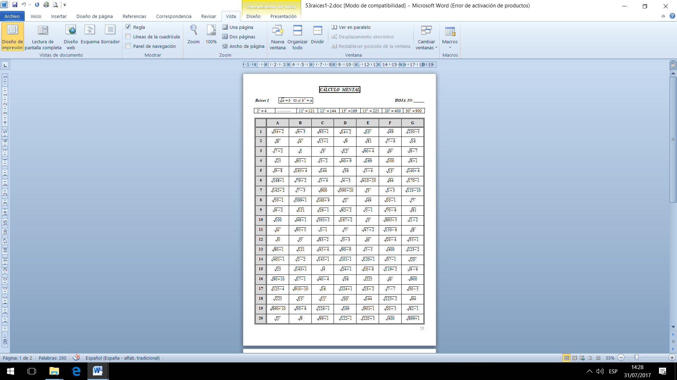

**HOJA DE RESPUESTAS**

***Raices 1***

|  |  |  |  |  |  |  |  |
| --- | --- | --- | --- | --- | --- | --- | --- |
|  | **A** | **B** | **C** | **D** | **E** | **F** | **G** |
| **1** |  |  |  |  |  |  |  |
| **2** |  |  |  |  |  |  |  |
| **3** |  |  |  |  |  |  |  |
| **4** |  |  |  |  |  |  |  |
| **5** |  |  |  |  |  |  |  |
| **6** |  |  |  |  |  |  |  |
| **7** |  |  |  |  |  |  |  |
| **8** |  |  |  |  |  |  |  |
| **9** |  |  |  |  |  |  |  |
| **10** |  |  |  |  |  |  |  |
| **11** |  |  |  |  |  |  |  |
| **12** |  |  |  |  |  |  |  |
| **13** |  |  |  |  |  |  |  |
| **14** |  |  |  |  |  |  |  |
| **15** |  |  |  |  |  |  |  |
| **16** |  |  |  |  |  |  |  |
| **17** |  |  |  |  |  |  |  |
| **18** |  |  |  |  |  |  |  |
| **19** |  |  |  |  |  |  |  |
| **20** |  |  |  |  |  |  |  |

**CÁLCULO MENTAL**

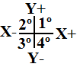**SEGUNDO GRADO**

***Puntos. Sitúa los puntos en los cuadrantes y semiejes correspondientes.***

|  |  |  |  |  |  |  |  |
| --- | --- | --- | --- | --- | --- | --- | --- |
|  | **A** | **B** | **C** | **D** | **E** | **F** | **G** |
| **1** | **(2 , 7)** | **(-4 , -3)** | **(-1 , 0)** | **(-1 , -2)** | **(5 , 0)** | **(6 , -2)** | **(1 , 1)** |
| **2** | **(3 , -2)** | **(0 , -5)** | **(4 , -3)** | **(0 , -1)** | **(1 , -3)** | **(-2 , 1)** | **(0 , -4)** |
| **3** | **(1 , 0)** | **(7 , -6)** | **(0 , 2)** | **(4 , -1)** | **(0 , -2)** | **(2 , -6)** | **(6 , 3)** |
| **4** | **(-6 , 3)** | **(-6 , 1)** | **(-5 , -6)** | **(-5 , 6)** | **(-3 , -1)** | **(6 , 0)** | **(4 , -7)** |
| **5** | **(0 , -7)** | **(5 , 3)** | **(5 , 1)** | **(4 , 0)** | **(3 , 6)** | **(-7 , 3)** | **(7 , 0)** |
| **6** | **(5 , -3)** | **(2 , 0)** | **(0 , -6)** | **(-3 , -3)** | **(-3 , 0)** | **(1 , 3)** | **(-5 , -2)** |
| **7** | **(-7 , -1)** | **(-7 , 5)** | **(-4 , -1)** | **(5 , -5)** | **(-4 , -5)** | **(0 , -3)** | **(-7 , 1)** |
| **8** | **(0 , 5)** | **(3 , 2)** | **(-3 , 3)** | **(0 , 3)** | **(2 , 1)** | **(-3 , 5)** | **(-2 , -6)** |
| **9** | **(5 , 5)** | **(0 , -10)** | **(3 , 0)** | **(6 , 7)** | **(5 , -7)** | **(0 , 7)** | **(2 , 5)** |
| **10** | **(-4 , 2)** | **(1 , -7)** | **(6 , 5)** | **(-3 , 1)** | **(-2 , 3)** | **(1 , -1)** | **(-5 , 0)** |
| **11** | **(-3 , -7)** | **(0 , 1)** | **(2 , -2)** | **(2 , 3)** | **(0 , 4)** | **(-5 , -4)** | **(3 , -4)** |
| **12** | **(-6 , 0)** | **(5 , -1)** | **(-1 , -4)** | **(-2 , 0)** | **(6 , -4)** | **(5 , 7)** | **(0 , 6)** |
| **13** | **(-2 , -4)** | **(-2 , 7)** | **(-1 , 2)** | **(-7 , -7)** | **(7 , 2)** | **(-4 , 0)** | **(-4 , 4)** |
| **14** | **(6 , 1)** | **(2 , -4)** | **(0 , -8)** | **(7 , -2)** | **(-5 , 4)** | **(-7 , -5)** | **(-8 , 0)** |
| **15** | **(1 , -5)** | **(9 , 0)** | **(1 , 7)** | **(7 , 4)** | **(-10 , 0)** | **(4 , 4)** | **(-7 , -3)** |
| **16** | **(-1 , 6)** | **(4 , -5)** | **(-6 , -6)** | **(0 , 8)** | **(4 , 6)** | **(-9 , 0)** | **(-6 , 5)** |
| **17** | **(8 , 0)** | **(-2 , -2)** | **(-7 , 7)** | **(-6 , -4)** | **(-6 , -2)** | **(-4 , -7)** | **(11, 0)** |
| **18** | **(3 , 4)** | **(-1 , 4)** | **(10 , 0)** | **(-2 , 5)** | **(-6 , 7)** | **(-5 , 2)** | **(-1 , -6)** |
| **19** | **(-11, 0)** | **(6 , -6)** | **(-3 , -5)** | **(0 , -9)** | **(0 , 9)** | **(3 , -6)** | **(4 , 2)** |
| **20** | **(7 , 6)** | **(-7 , 0)** | **(7 , -4)** | **(-4 , 6)** | **(1 , 5)** | **(0 , 10)** | **(-3 , 7)** |

**HOJA DE RESPUESTAS**

***Puntos. Sitúa los puntos en los cuadrantes y semiejes correspondientes.***

|  |  |  |  |  |  |  |  |
| --- | --- | --- | --- | --- | --- | --- | --- |
|  | **A** | **B** | **C** | **D** | **E** | **F** | **G** |
| **1** |  |  |  |  |  |  |  |
| **2** |  |  |  |  |  |  |  |
| **3** |  |  |  |  |  |  |  |
| **4** |  |  |  |  |  |  |  |
| **5** |  |  |  |  |  |  |  |
| **6** |  |  |  |  |  |  |  |
| **7** |  |  |  |  |  |  |  |
| **8** |  |  |  |  |  |  |  |
| **9** |  |  |  |  |  |  |  |
| **10** |  |  |  |  |  |  |  |
| **11** |  |  |  |  |  |  |  |
| **12** |  |  |  |  |  |  |  |
| **13** |  |  |  |  |  |  |  |
| **14** |  |  |  |  |  |  |  |
| **15** |  |  |  |  |  |  |  |
| **16** |  |  |  |  |  |  |  |
| **17** |  |  |  |  |  |  |  |
| **18** |  |  |  |  |  |  |  |
| **19** |  |  |  |  |  |  |  |
| **20** |  |  |  |  |  |  |  |

**CÁLCULO MENTAL**

**SEGUNDO GRADO**

***Funciones 1. Calcula la imagen de un valor en una función lineal.(Dado x calcula y)***

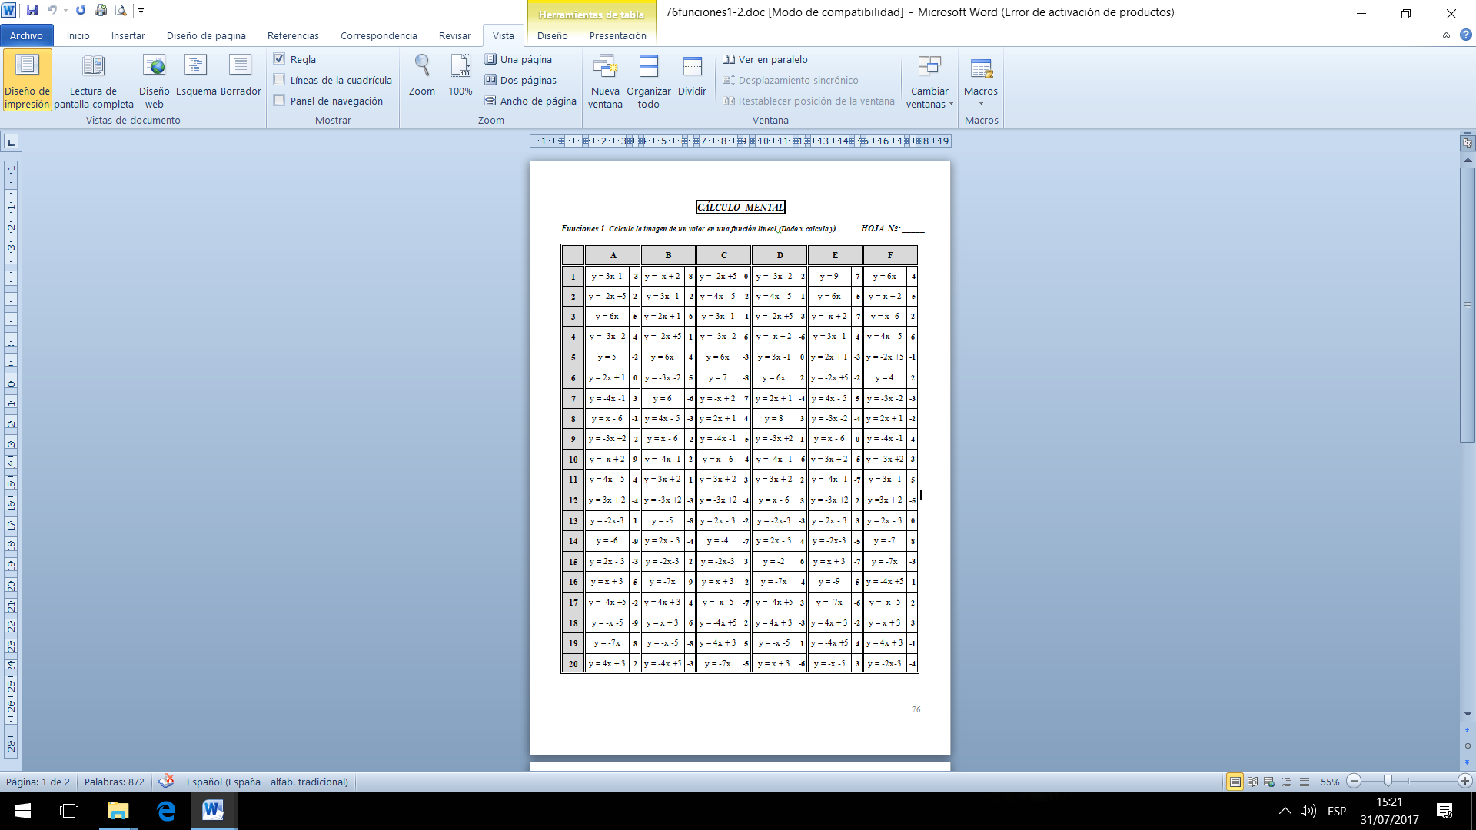

**HOJA DE RESPUESTAS**

***Funciones 1. Calcula la imagen de un valor en una función lineal.(Dado x calcula y)***

|  |  |  |  |  |  |  |
| --- | --- | --- | --- | --- | --- | --- |
|  | **A** | **B** | **C** | **D** | **E** | **F** |
| **1** |  |  |  |  |  |  |
| **2** |  |  |  |  |  |  |
| **3** |  |  |  |  |  |  |
| **4** |  |  |  |  |  |  |
| **5** |  |  |  |  |  |  |
| **6** |  |  |  |  |  |  |
| **7** |  |  |  |  |  |  |
| **8** |  |  |  |  |  |  |
| **9** |  |  |  |  |  |  |
| **10** |  |  |  |  |  |  |
| **11** |  |  |  |  |  |  |
| **12** |  |  |  |  |  |  |
| **13** |  |  |  |  |  |  |
| **14** |  |  |  |  |  |  |
| **15** |  |  |  |  |  |  |
| **16** |  |  |  |  |  |  |
| **17** |  |  |  |  |  |  |
| **18** |  |  |  |  |  |  |
| **19** |  |  |  |  |  |  |
| **20** |  |  |  |  |  |  |

**CÁLCULO MENTAL**

**SEGUNDO GRADO**

***Funciones 2. Calcula la imagen de un valor en una función lineal.(Dado x calcula y)***

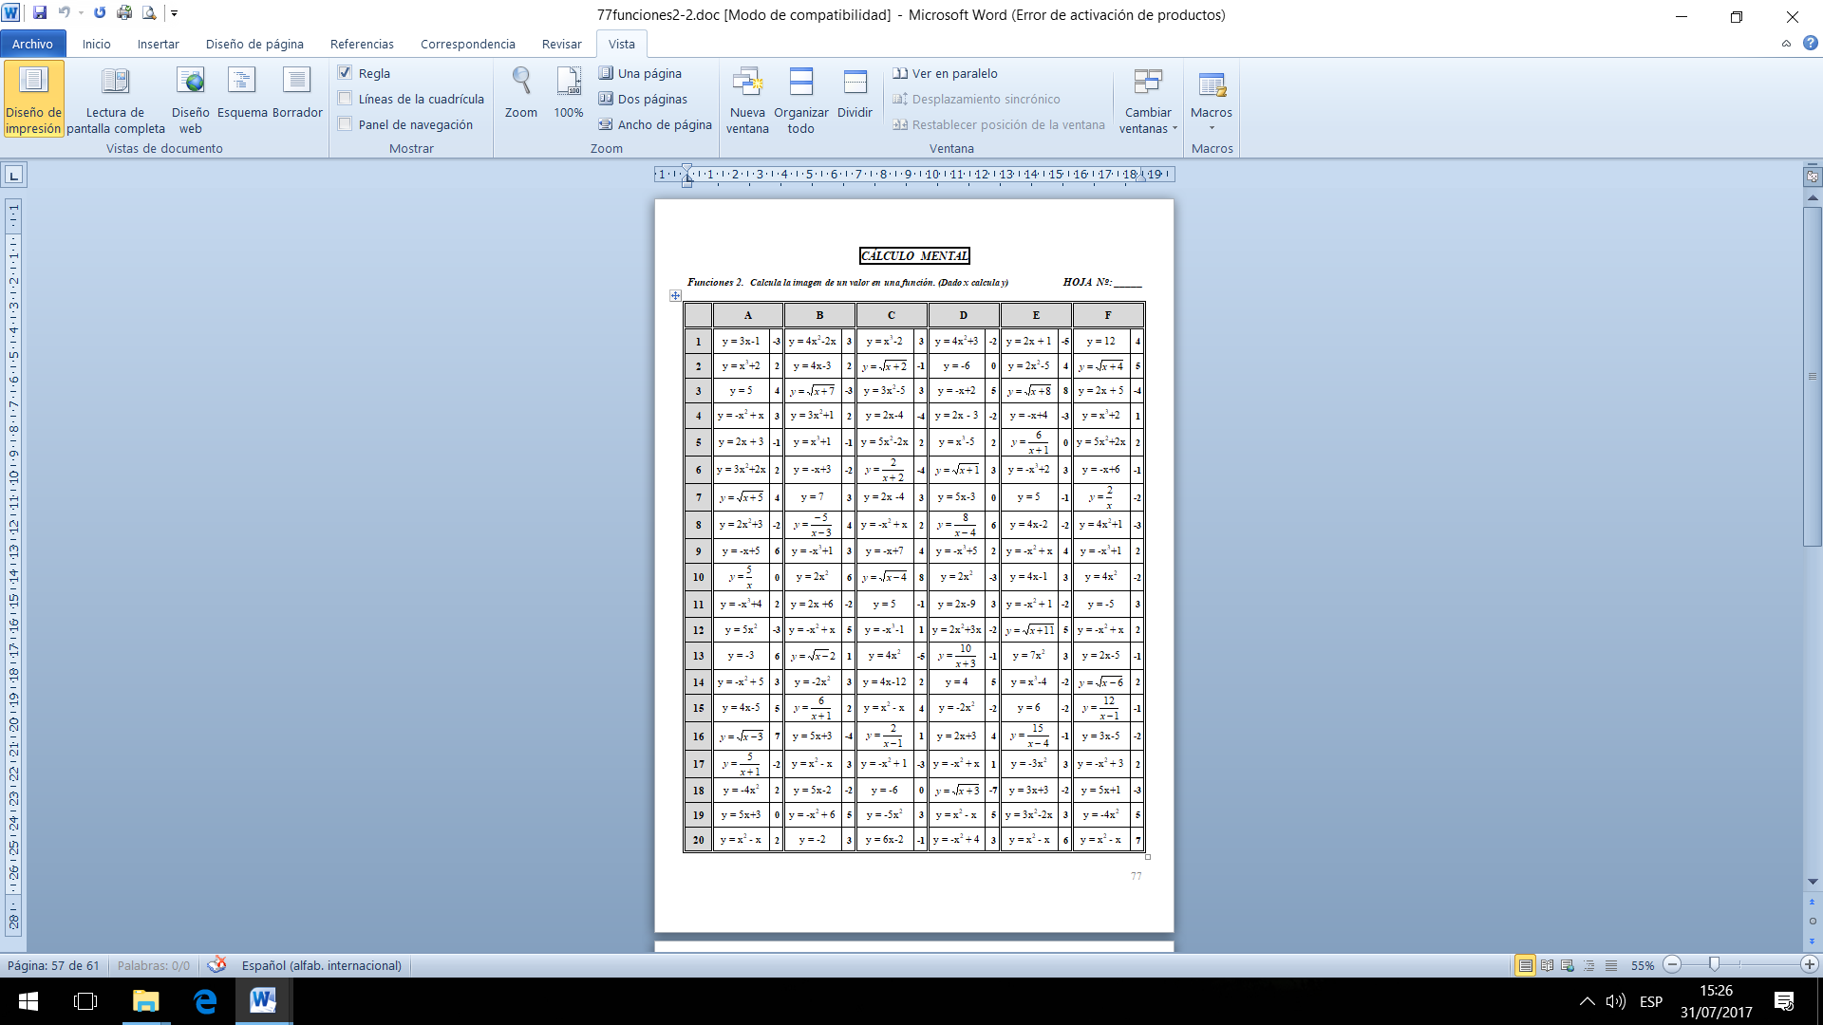

**HOJA DE RESPUESTAS**

***Funciones2. Calcula la imagen de un valor en una función lineal.(Dado x calcula y)***

|  |  |  |  |  |  |  |
| --- | --- | --- | --- | --- | --- | --- |
|  | **A** | **B** | **C** | **D** | **E** | **F** |
| **1** |  |  |  |  |  |  |
| **2** |  |  |  |  |  |  |
| **3** |  |  |  |  |  |  |
| **4** |  |  |  |  |  |  |
| **5** |  |  |  |  |  |  |
| **6** |  |  |  |  |  |  |
| **7** |  |  |  |  |  |  |
| **8** |  |  |  |  |  |  |
| **9** |  |  |  |  |  |  |
| **10** |  |  |  |  |  |  |
| **11** |  |  |  |  |  |  |
| **12** |  |  |  |  |  |  |
| **13** |  |  |  |  |  |  |
| **14** |  |  |  |  |  |  |
| **15** |  |  |  |  |  |  |
| **16** |  |  |  |  |  |  |
| **17** |  |  |  |  |  |  |
| **18** |  |  |  |  |  |  |
| **19** |  |  |  |  |  |  |
| **20** |  |  |  |  |  |  |

**CÁLCULO MENTAL**

**SEGUNDO GRADO**

***Progresiones ¿Cuál es la razón r o la diferencia d en estas progresiones?***

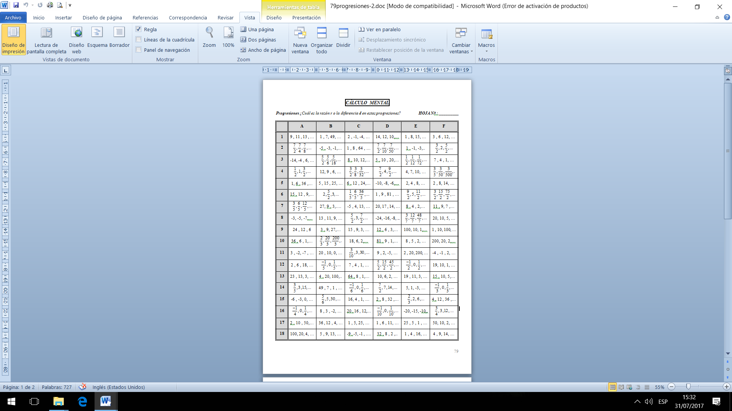

**HOJA DE RESPUESTAS**

***Progresiones ¿Cuál es la razón r o la diferencia d en estas progresiones?***

|  |  |  |  |  |  |  |
| --- | --- | --- | --- | --- | --- | --- |
|  | **A** | **B** | **C** | **D** | **E** | **F** |
| **1** |  |  |  |  |  |  |
| **2** |  |  |  |  |  |  |
| **3** |  |  |  |  |  |  |
| **4** |  |  |  |  |  |  |
| **5** |  |  |  |  |  |  |
| **6** |  |  |  |  |  |  |
| **7** |  |  |  |  |  |  |
| **8** |  |  |  |  |  |  |
| **9** |  |  |  |  |  |  |
| **10** |  |  |  |  |  |  |
| **11** |  |  |  |  |  |  |
| **12** |  |  |  |  |  |  |
| **13** |  |  |  |  |  |  |
| **14** |  |  |  |  |  |  |
| **15** |  |  |  |  |  |  |
| **16** |  |  |  |  |  |  |
| **17** |  |  |  |  |  |  |
| **18** |  |  |  |  |  |  |

**CÁLCULO MENTAL**

**SEGUNDO GRADO**

***Identidades notables.(Factorizar o expandir una expresión)*** 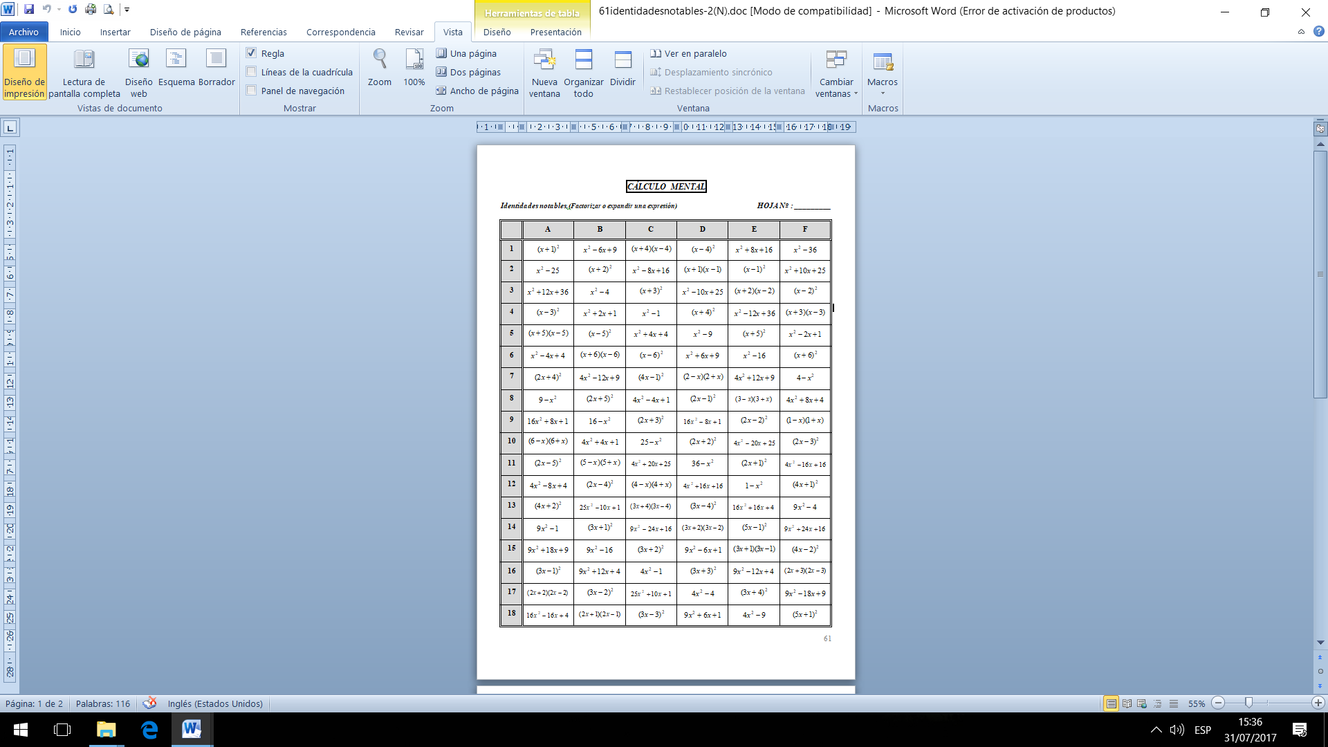

**HOJA DE RESPUESTAS**

***Identidades notables.(Factorizar o expandir una expresión)***

|  |  |  |  |  |  |  |
| --- | --- | --- | --- | --- | --- | --- |
|  | **A** | **B** | **C** | **D** | **E** | **F** |
| **1** |  |  |  |  |  |  |
| **2** |  |  |  |  |  |  |
| **3** |  |  |  |  |  |  |
| **4** |  |  |  |  |  |  |
| **5** |  |  |  |  |  |  |
| **6** |  |  |  |  |  |  |
| **7** |  |  |  |  |  |  |
| **8** |  |  |  |  |  |  |
| **9** |  |  |  |  |  |  |
| **10** |  |  |  |  |  |  |
| **11** |  |  |  |  |  |  |
| **12** |  |  |  |  |  |  |
| **13** |  |  |  |  |  |  |
| **14** |  |  |  |  |  |  |
| **15** |  |  |  |  |  |  |
| **16** |  |  |  |  |  |  |
| **17** |  |  |  |  |  |  |
| **18** |  |  |  |  |  |  |

**CÁLCULO MENTAL**

**SEGUNDO GRADO**

***Descomposición factorial (números < 100)***

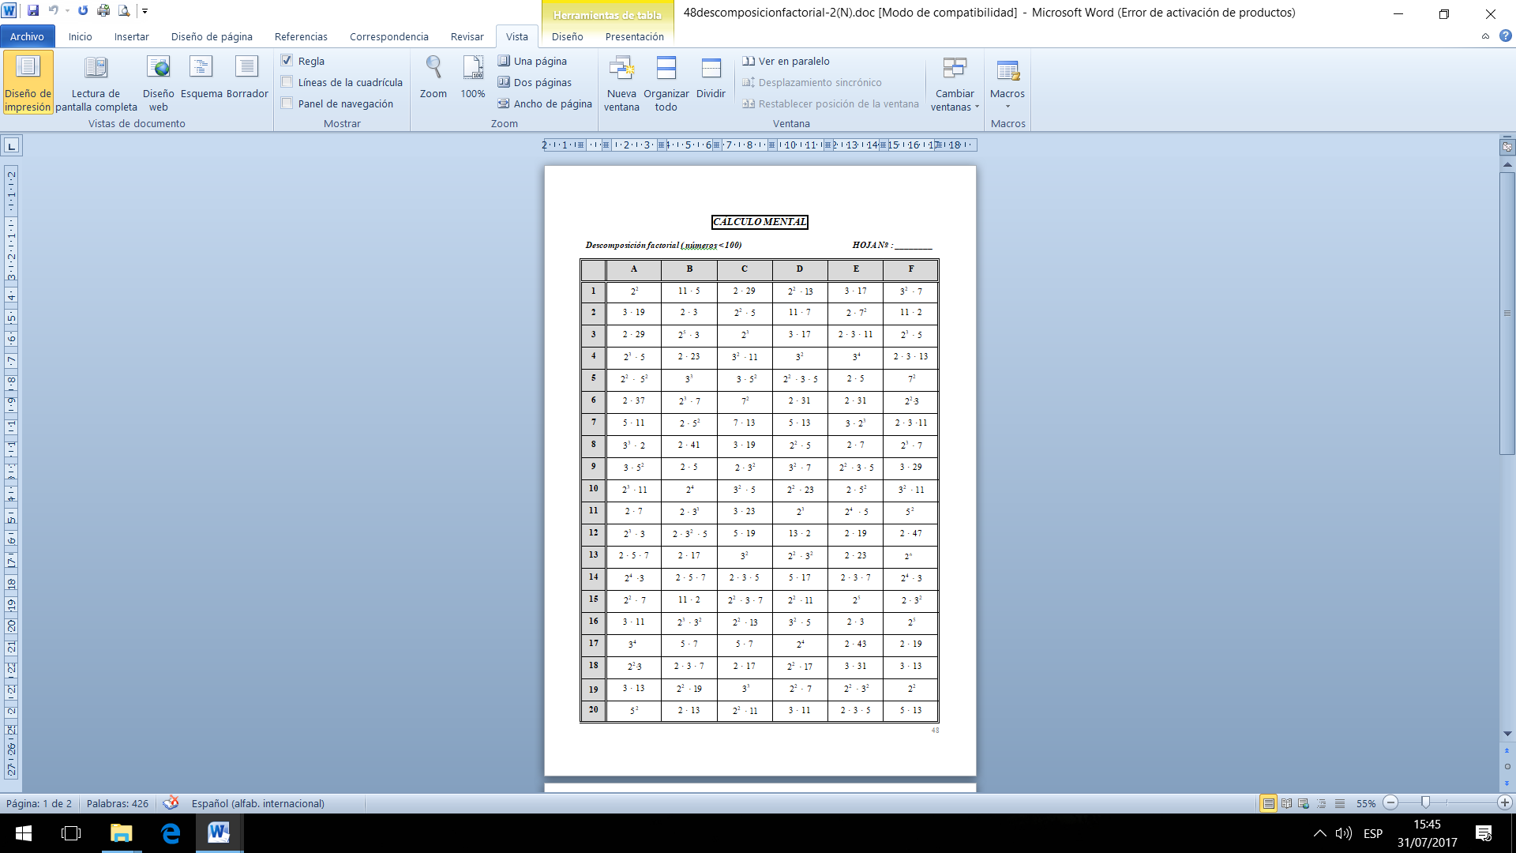

**HOJA DE RESPUESTAS**

***Descomposición factorial (números < 100)***

|  |  |  |  |  |  |  |
| --- | --- | --- | --- | --- | --- | --- |
|  | **A** | **B** | **C** | **D** | **E** | **F** |
| **1** |  |  |  |  |  |  |
| **2** |  |  |  |  |  |  |
| **3** |  |  |  |  |  |  |
| **4** |  |  |  |  |  |  |
| **5** |  |  |  |  |  |  |
| **6** |  |  |  |  |  |  |
| **7** |  |  |  |  |  |  |
| **8** |  |  |  |  |  |  |
| **9** |  |  |  |  |  |  |
| **10** |  |  |  |  |  |  |
| **11** |  |  |  |  |  |  |
| **12** |  |  |  |  |  |  |
| **13** |  |  |  |  |  |  |
| **14** |  |  |  |  |  |  |
| **15** |  |  |  |  |  |  |
| **16** |  |  |  |  |  |  |
| **17** |  |  |  |  |  |  |
| **18** |  |  |  |  |  |  |
| **19** |  |  |  |  |  |  |
| **20** |  |  |  |  |  |  |